 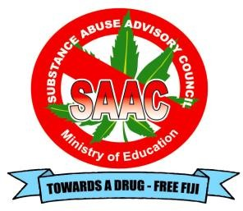



### “UNDERSTANDING AND SHARING FACTS ON DRUGS: SAVE LIVES.”

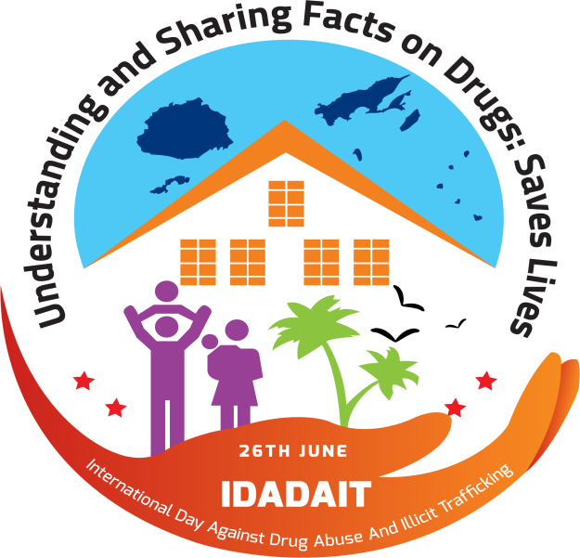

**EVALUATION FORM**

**2023**

SUBSTANCE ABUSE ADVISORY COUNCIL

1. Name of School:
2. School Code:
3. Education District:
4. Name of School Head:
5. School Roll: Male: Female:
6. Name of School Child Protection Officer (CPO): TPF:

**SCHOOL DATA**

**All school heads are requested to fill in the relevant data which were formally recorded in their school in the appropriate table below. Please note that all data provided are confidential. It will only be used for the purpose of planning and addressing the social issues affecting students.**

## DRUG AND SUBSTANCE ABUSE

1. Please provide latest data in your school on any **Drug and Substance Abuse Offences**

reported in school where students are involved from **August 2022 – 31st July 2023**?

Please indicate your response with number of students

|  |  |  |  |
| --- | --- | --- | --- |
| **Alcohol & Other Drugs (AOD)** | **Male** | **Female** | **TOTAL CASES** |
| **Kava – yaqona** |  |  |  |
| **Tobacco/ cigarette** |  |  |  |
| **Suki [Fijian cigar]** |  |  |  |
| **Alcohol[beer, spirit, wine]** |  |  |  |
| **Inhalants (Glue, Benzene, Thinners, etc.)** |  |  |  |
| **Home brew** |  |  |  |
| **Methylated Spirit** |  |  |  |
| **Cannabis - Marijuana** |  |  |  |
| **Hard Drugs**   * ***Methamphetamine*** |  |  |  |
| * ***Cocaine*** |  |  |  |
| * ***Heroin*** |  |  |  |
| * ***Other Drugs [Please specify]*** |  |  |  |
| **Drug dealing / peddling in school [legal/illegal] both?** |  |  |  |
| **TOTAL OFFENCES** |  |  |  |

## SEXUAL RELATED OFFENCES

1. Please provide latest data from your school on any **Sexual Related Offences** reported from

**August 2022 – 31st July 2023**?

**Rape** – to enter (to any extent) the genitalia or anus of a person by any part of the body of another person or by any object used by that other person/ penetrate (to any extent) the mouth of a person by the penis of another person.

**Attempted Rape** Any person who attempts to commit rape is guilty of a felony

**Sexual Harassment** unwelcome **sexual** advances, requests for **sexual** favors, and other verbal or physical conduct of a **sexual** nature.

**Defilement** is any person who attempt or engage in a sexual act with a child who is above the age of 13 and below the age of 16 years.

**Poking is a jab** or dig (something), especially with one's finger on private space.

**Teenage Pregnancy is** also known as adolescent pregnancy, is pregnancy in a female under the age of 18.

Please indicate your responses in number of students*

|  |  |  |  |  |  |  |
| --- | --- | --- | --- | --- | --- | --- |
| **Sex Related Offence** | **Perpetrator** | | **TOTAL** | **Victim** | | **TOTAL** |
| **Male** | **Female** | **Male** | **Female** |
| ***Rape*** |  |  |  |  |  |  |
| ***Attempted Rape*** |  |  |  |  |  |  |
| ***Sexual Harassment (insulting remarks,***  ***offensive graffiti, whistling at someone, cat calls)*** |  |  |  |  |  |  |
| ***Defilement*** |  |  |  |  |  |  |
| ***Poking*** |  |  |  |  |  |  |
| ***Teenage Pregnancy*** |  |  |  |  |  |  |
| **TOTAL OFFENCES** |  |  |  |  |  |  |

# VIOLENCE

1. Please provide latest data in your school on any **Violence committed against Students** from **August 2022 – 31st July 2023** in the table below?

**Violence** – is a threat of force such as that caused by fear of violence, pressure, detention, psychological harassment or abuse of power/taking advantage of a bullying environment.

**Bullying** - repeated misuse of power, either physical or intellectual by an individual or a group of individuals onto another less powerful person.

**Punching** - to hit (someone) with a powerful punch, often so as to render unconscious.

**Beating** - to hit a person repeatedly so as to cause painful injury.

**Slapping** - to strike (a person) sharply, as with the open hand or something flat.

**Swearing** - to use bad or vulgar language at someone.

**Disrespectful** - showing a lack of respect or courtesy/impolite.

**Name calling** - (teasing/belittling) using abusive language or insult at anyone.

Please indicate your responses in number of students*

|  |  |  |  |  |  |  |
| --- | --- | --- | --- | --- | --- | --- |
| **Violent Offences** | **Perpetrator** | | **TOTAL** | **Victim** | | **TOTAL** |
| **Male** | **Female** | **Male** | **Female** |
| * ***Bullying*** |  |  |  |  |  |  |
| * ***Punching*** |  |  |  |  |  |  |
| * ***Beating*** |  |  |  |  |  |  |
| * ***Slapping*** |  |  |  |  |  |  |
| * ***Swearing*** |  |  |  |  |  |  |
| * ***Disrespectful*** |  |  |  |  |  |  |
| * ***Name calling (teasing/belittling)*** |  |  |  |  |  |  |
| **TOTAL OFFENCES** |  |  |  |  |  |  |

## SOCIAL MEDIA

1. Please provide latest data in your school on any **Social Media Offences for both [Perpetrator and Victim]** from **August 2022 – 31st July 2023** in the table below?

**Social Media Offences** - any individual who has a reason to believe that he or she is the target or recipient of electronic communication intended or likely to cause harm.

**Cyber bullying** – involves the use of information and communication technologies such as e-mail, text messages, instant messages, and web sites to engage in the bullying of other individuals or groups of people.

**Sexting** - the action or practice of sending sexually explicit photographs or messages via mobile phone.

**Pornography**- Sexually explicit writing, images, video, or other material whose primary purpose is to cause sexual arousal.

**Grooming** - when someone (often an adult) befriends a child online and builds an emotional connection with future intentions of sexual abuse, sexual exploitation or trafficking

**Cyber stalking** - threatening behavior or unwanted advances directed at another person using the Internet and other forms of online and computer for example by sending threatening emails.

**Cyber predators**: are people who use the internet to lie about their personal detail to gain the trust of young people and exploit them for sexual and other purposes.

**Revenge porn:** revealing or sexually explicit images or video of a person posted on internet typically by former sexual partners without the consent of the subject to cause embarrassment and distress.

**Please indicate your responses in number of students\***

|  |  |  |  |  |  |  |
| --- | --- | --- | --- | --- | --- | --- |
| **Social Media Offences** | **Perpetrator** | | **TOTAL** | **Victim** | | **TOTAL** |
| **Male** | **Female** | **Male** | **Female** |
| * **Cyber bullying** |  |  |  |  |  |  |
| * ***Sexting*** |  |  |  |  |  |  |
| * ***Pornography*** |  |  |  |  |  |  |
| * ***Grooming*** |  |  |  |  |  |  |
| * ***Cyber stalking*** |  |  |  |  |  |  |
| * ***Cyber Predators*** |  |  |  |  |  |  |
| * ***Revenge porn*** |  |  |  |  |  |  |
| **TOTAL OFFENCES** |  |  |  |  |  |  |

# OTHER ISSUES

1. Please provide latest data on the issues given below reported in school from **August 2022 – 31st July 2023?**

**Truancy -** is the action of staying away from school without good reason.

**Suspension -** is a form of school discipline which temporarily removes a student from a class or from school.

**Find Another School -** a student advised to look for and attend another school for various reasons.

**Dropping out of school** – is the leaving of the school (system) for various reasons.

**Romantic Relationship** - emotional or physical relationship with a person.

**Self –Harm-** is a non-fatal, self-directed, possibly injurious behavior with intent to die as a result of the behavior.

**Suicide -** is the act of intentionally causing one's own death.

**Please indicate your responses in number of students\***

|  |  |  |  |
| --- | --- | --- | --- |
| **Other Issues** | **SEX** | | **Reasons** |
| **Male** | **Female** |
| ***Truancy*** |  |  |  |
| ***Suspended from school*** |  |  |  |
| ***Find another school*** |  |  |  |
| ***Dropping out of school*** |  |  |  |
| ***Romantic relationship*** |  |  |  |
| ***Self-Harm*** |  |  |  |
| ***Suicide*** |  |  |  |
| **TOTAL** |  |  |  |

**IDADAIT SCHOOL BASED PROGRAMME**

1. **Briefly state activities that your school has done to address these issues:**

|  |  |  |
| --- | --- | --- |
| **DAYS** | **TOPICS** | **ACTIVITIES** |
| **Monday**  **03/07/23**  **(White Day)** | **Reducing Violence** |  |
| **Tuesday**  **04/07/23**  **(Blue Day)** | **Social Media Safety** |  |
| **Wednesday**  **05/07/23**  **(Purple Day)** | **Sex-Related Offences** |  |
| **Thursday**  **06/07/23**  **(Green Day)** | **Mental Health & Healthy Life Style** |  |
| **Friday**  **07/07/23**  **(Red Day)** | **Drugs** |  |

1. Please provide your recommendations for the improvement of the **2024 International Day Against Drug Abuse & Illicit Trafficking (IDADAIT**), *Drugs and Substance Abuse, HIV AIDS/STI prevention & teenage pregnancy, Stop Child Abuse & Violence in schools, Social Media awareness and promoting Wellness & Mental Health*

………………………………………………………………………………………………………………………………………………

………………………………………………………………………………………………………………………………………………

……………………………………………………………………………………………………………………………………………

1. **Name and particulars of Teachers/Drug Free Coordinators or Child Protection Officers that filled the form**

|  |  |  |  |  |  |
| --- | --- | --- | --- | --- | --- |
| **Name** | **Designation** | **TPF** | **Phone Contact** | **Date** | **Signature** |
|  |  |  |  |  |  |

**Declaration**

I……………………………………….…….hereby declare that the information furnished in this form is true, complete and correct to the best of my knowledge and belief.

**Name of HOS: ……………………………………**

**Date: ………………….. Signature: …………………………**

**NOTE**

SCHOOL HEADS ARE KINDLY REQUESTED TO EITHER **SUBMIT/EMAIL** OR **SCAN AND SUBMIT** THE

EVALUATION FORM TO SAAC OFFICE BEFORE THE 31ST OF AUGUST, 2023.

ALL FORMS TO BE ADDRESSED TO CEO SAAC, P O BOX 2565, GOVERNMENT BUILDING, SUVA

**EMAIL:** [**nsaaccouncil@gmail.com**](mailto:nsaaccouncil@gmail.com)

**Phone: 3394 144 / 3394 180/7734 180**