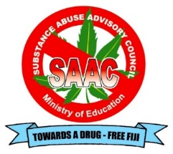

**IDADAIT SCHOOL ACTIVITY BOOKLET**

**2023**

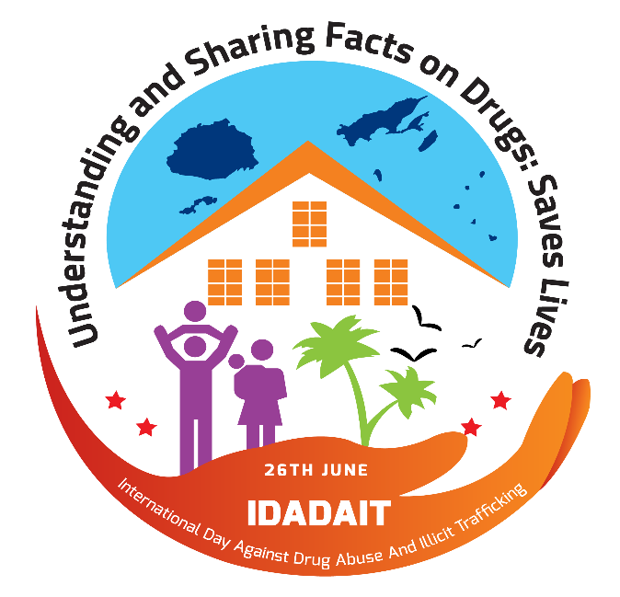

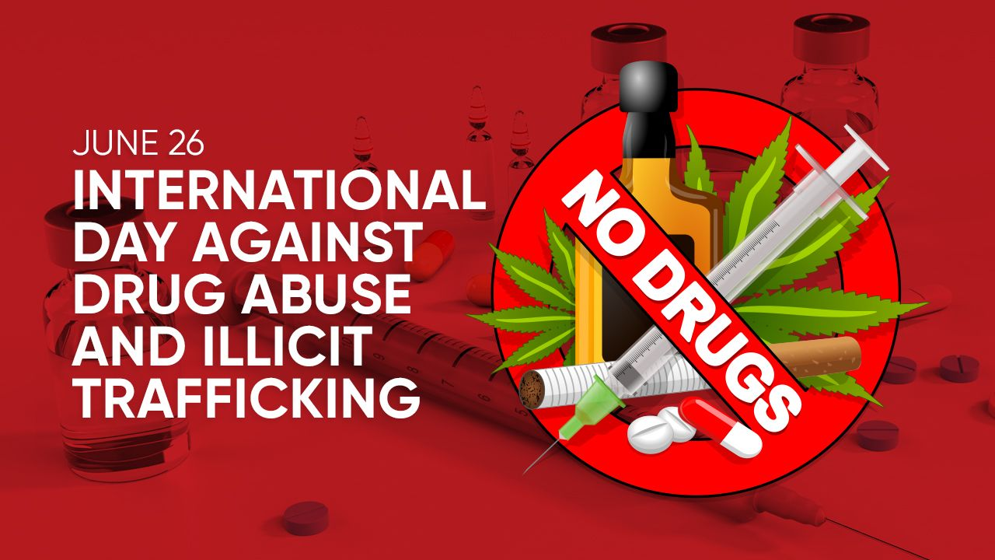

**INTERNATIONAL DAY AGAINST DRUG ABUSE AND ILLICIT TRAFFICKING (IDADAIT) - School Based Activities**

**IDADAIT stands for International Day against Drug Abuse and Illicit Trafficking. The aim is to reduce the incidents and minimize the impact of drugs and substances abuse in our schools by promoting healthy lifestyles through awareness and education. It also provides interventions such as counselling for young people affected by substance and drug abuse in schools.**

**The commemoration of IDADAIT in Fiji schools since 2008 has evolved over the years with the inclusion of many social issues, but majorly focusing on:**

* ***Prevention of Suicide - Promoting Good Mental Health***
* ***Reduce Alcohol and Other Drugs***

**The IDADAIT Campaign has been successfully implemented in all schools in Fiji due to tremendous involvement of students, teachers, school managements, parents and other stakeholders.**

**Teachers and students have kindly given their time, talent, energy and resources to create a well-recognized school based campaign on the very close relationship between drugs and substance abuse, with other related issues. Thus, this year’s IDADAIT celebration not only focuses on combating drugs, but also looks at reducing violence, promoting social media safety, reducing sex related offences, having a good mental health and healthy lifestyle.**

**We invite you to join with the millions around the globe as we proclaim our support and dedication to the creation of healthy school environment that promote and support healthy children.**

**School communities are a powerful resource and children are our future.**

**NOTE: The activities must NOT depict or display any self-harm or death /suicide.**

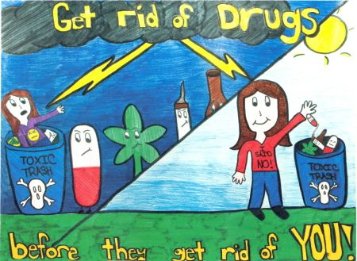

**IDADAIT Awareness Day**

**School Based Activities**

**MONDAY**

**(26/06/23)**

**“DRUGS”**

**Wear “RED”**

**Sub-theme:**

**“A Healthy me, is drug free”**

**Monday 03/07/23**

**“REDUCING VIOLENCE”**

**“Setting a Peaceful Environment”**

**PRIMARY SCHOOL LEVELS**

1. **Short poetry recital** – students to prepare short poems, drawings and display to their classroom
2. **Book markers** –students can collect old buttons, strings and pins to decorate simple book marks with class.
3. **Short skit** – Base on theme, teachers must provide a short plays to their class.
4. **Short song** – student to write a short songs about the theme.
5. **Model Display** – teachers should set model display for their classroom base on the theme.
6. **Narrative Essay (maximum 150 words)** – Teacher can organize oratory competition for students only 80 words base on the theme.
7. **Short Oratory** – Students can prepare short oratory speech during morning talk base on the theme.
8. **Poster Competition** - teachers to organize Poster Competition for students based on the theme.
9. **School Pledge** – the school writes a creative pledge “Reducing Violence” – students take this pledge.
10. **Debate –** teachers organize an inter-form debate on “Violence needs to be reported”.
11. **Panel discussion –** students divided into groups of five – free discussion on “awareness needed to reduce violence.”
12. **Classroom/bulletin Corner booth display** – teachers can display all charts and student’s work at the Corner Booth and divide the class for the decoration based on the theme.

***(The School Coordinator/HOS – to decide which activity they want to carry on the days)***

**SECONDARY SCHOOL LEVELS**

1. **Poetry recital** – students to prepare poetry based on the theme and have it pasted at their classroom organization board.
2. **Banner Display** – students to prepare banner based on the theme and have it displayed in their own classrooms.
3. **Role-play** - students to prepare role-play based on the theme.
4. **Song** – teachers to organize song competition for students based on the theme.
5. **Model Display** – teachers to organize model display competition for students based on the theme.
6. **Advertisement advocacy (TV/Radio)** – students to prepare TV/Radio Advertisement advocacy based on theme.
7. **Diary Entry (maximum 100 words)** – students to prepare Diary Entry based on theme.
8. **Poster Competition** – teachers to organize Poster Competition for students based on the theme.
9. **School Pledge** – the school writes a creative pledge “Reducing Violence” – students take this pledge**.**
10. **Debate –** teachers organize an inter-form debate on “Violence needs to be reported”.
11. **Panel discussion –** students divided into groups of five – free discussion on “Awareness needed to reduce Violence.”
12. **Classroom/bulletin Corner booth display** - teachers to organize Classroom/Bulletin Corner Booth Display competition for students based on the theme- eg: “design a big Heart & paste information.

***(The School Coordinator/HOS – to decide which activity they want to carry on the days)***

|  |
| --- |
| **ADDITIONAL ACTIVITIES TO SUIT THE DAY** |

1. **School Assemblies** –Principal/AP or Child Protection Officer must gather relevant datafrom Activity Book and present to the schools the amount of offences their District has produced.
2. **Invite the Fiji Sexual Offence Unit, Community Policing, Juvenile Bureau, Police Human Traffic Unit, Ministry of Health, and Pacific Centre for Peacebuilding, Social Welfare Departmen**t, **Legal Aid Commission, Education officers, Fiji Women’s Crisis Centre, Fiji Women Right Movement, Homes of Hope** *and other* ***NGOs*** *to talk about Child Abuse, Eliminate all**forms of violence in schools.*
3. **Form Time** –Ask the student to write on the blank paper how to prevent Violence andChild Abuse in schools. Students to be encouraged to draw posters that promote Love and Respect.
4. **Invite speakers** *from a Successful Old scholars to talk in school, faith based, civil**society’s leaders or community leaders to launch or close the week long commemoration of IDADAIT.*
5. **Display White color (optional) –** display White colors on trees, door knobs, fences, desks, tables,etc.

**Tuesday 04/07/23**

**“SOCIAL MEDIA SAFETY”**

**“To be a good online Citizen”**

**PRIMARY SCHOOL LEVELS**

1. **Short poetry recital** – students to prepare short poems, drawings and display to their classroom
2. **Book markers** –students can collect old buttons, strings and pins to decorate simple book marks with class.
3. **Short skit** – Base on theme, teachers must provide a short plays to their class.
4. **Short song** – student to write a short songs about the theme.
5. **Model Display** – teachers should set model display for their classroom base on the theme.
6. **Narrative Essay (maximum 150 words)** – Teacher can organize oratory competition for students only 80 words base on the theme.
7. **Short Oratory** – Students can prepare short oratory speech during morning talk base on the theme.
8. **Poster Competition** - teachers to organize Poster Competition for students based on the theme.
9. **School Pledge** – the school writes a creative pledge “Social Media Safety” – students take this pledge.
10. **Debate –** teachers organize an inter-form debate on “Pro’s and Con’s of Social Media Usage”.
11. **Panel discussion –** students divided into groups of five – free discussion on “Social Media Safety.”
12. **Classroom/bulletin Corner booth display** – teachers can display all charts and student’s work at the Corner Booth and divide the class for the decoration based on the theme.

***(The School Coordinator/HOS – to decide which activity they want to carry on the days)***

**SECONDARY SCHOOL LEVELS**

1. **Poetry recital** – students to prepare poetry based on the theme and have it pasted at their classroom organization board.
2. **Banner Display** – students to prepare banner based on the theme and have it displayed in their own classrooms.
3. **Role-play** - students to prepare role-play based on the theme.
4. **Song** – teachers to organize song competition for students based on the theme.
5. **Model Display** – teachers to organize model display competition for students based on the theme.
6. **Advertisement advocacy (TV/Radio)** – students to prepare TV/Radio Advertisement advocacy based on theme.
7. **Diary Entry (maximum 100 words)** – students to prepare Diary Entry based on theme.
8. **Poster Competition** – teachers to organize Poster Competition for students based on the theme.
9. **School Pledge** – the school writes a creative pledge “Social Media Safety” – students take this pledge.
10. **Debate –** teachers organize an inter-form debate on “Pro’s and Con’s of Social Media Usage”.
11. **Panel discussion –** students divided into groups of five – free discussion on “Social Media Safety.”
12. Prefects to present to the students on the Theme of the day
13. **Classroom/bulletin Corner booth display** - teachers to organize Classroom/Bulletin Corner Booth Display competition for students based on the theme.

***(The School Coordinator/HOS – to decide which activity they want to carry on the days)***

|  |
| --- |
| **ADDITIONAL ACTIVITIES TO SUIT THE DAY** |

1. **Invite speakers** from the **Police Cybercrime Unit,** **Information Technology Computing Services [ITC],** **Juvenile Bureau, Community Policing, Legal Aid Commission,** **Online Safety Commission** and **Media Watch Fiji** to conduct presentations the safety of social media and the impact.
2. **Engage computer teachers to talk about online safety**
3. **Organize school based/Year levels activities - Prevent cyberbullying**:[Cyberbullying](http://www.stopbullying.gov/cyberbullying/what-is-it/index.html)—[bullying](http://www.stopbullying.gov/what-is-bullying/index.html) using electronic technology—can happen anytime and anywhere. Teach students to think through what they post on the Net or Facebook about other people and the [consequences](https://www.onguardonline.gov/articles/0028-cyberbullying) those posts could have if they are unkind or mean. Also, keep communication with the student to open and speak up if you suspect someone is bullying him or her.

* **Be Cyber wise – focus on cyber safety, cyber security and cyber ethics:**
* **Cyber safety**: be responsible and respectful while using online technology.
* **Cyber security**: keep personal information safe and not sharing password**.**
* **Cyber ethics:** Respect fellow cyber citizens and Nurture his/her self-confidence.

1. **Display Blue color (optional) –** display **Blue** colors on trees, door knobs, fences, desks, tables,etc.

**Wednesday 05/07/23**

**“Reducing Sex-Related Offences”**

**“Break the Silence to End Sexual Abuse”**

**PRIMARY SCHOOL LEVELS**

1. **Short poetry recital** – students to prepare short poems, drawings and display to their classroom
2. **Book markers** –students can collect old buttons, strings and pins to decorate simple book marks with class.
3. **Short skit** – Base on theme, teachers must provide a short plays to their class.
4. **Short song** – student to write a short songs about the theme.
5. **Model Display** – teachers should set model display for their classroom base on the theme.
6. **Narrative Essay (maximum 150 words)** – Teacher can organize oratory competition for students only 80 words base on the theme.
7. **Short Oratory** – Students can prepare short oratory speech during morning talk base on the theme.
8. **Poster Competition** - teachers to organize Poster Competition for students based on the theme
9. **School Pledge** – the school writes a creative pledge “Reducing Sex-related Offences” – students take this pledge.
10. **Debate –** teachers organize an inter-form debate on “Break the silence to reduce sexual abuse”.
11. **Panel discussion –** students divided into groups of five – free discussion on “reporting on sexual abuse cases and recovery.”
12. **Classroom/bulletin Corner booth display** – teachers can display all charts and student’s work at the Corner Booth and divide the class for the decoration based on the theme.

***(The School Coordinator/HOS – to decide which activity they want to carry on the days)***

**SECONDARY SCHOOL LEVELS**

1. **Poetry recital** – students to prepare poetry based on the theme and have it pasted at their classroom organization board.
2. **Banner Display** – students to prepare banner based on the theme and have it displayed in their own classrooms.
3. **Role-play** - students to prepare role-play based on the theme.
4. **Song** – teachers to organize song competition for students based on the theme.
5. **Model Display** – teachers to organize model display competition for students based on the theme.
6. **Advertisement advocacy (TV/Radio)** – students to prepare TV/Radio Advertisement advocacy based on theme.
7. **Diary Entry (maximum 100 words)** – students to prepare Diary Entry based on theme.
8. **Poster Competition** – teachers to organize Poster Competition for students based on the theme.
9. **School Pledge** – the school writes a creative pledge “Reducing Sex-related Offences” – students take this pledge.
10. **Debate –** teachers organize an inter-form debate on “Break the silence to reduce sexual abuse”.
11. **Panel discussion –** students divided into groups of five – free discussion on “reporting on sexual abuse cases and recovery.”
12. Prefects to present to the students on the Theme of the day
13. **Classroom/bulletin Corner booth display** - teachers to organize Classroom/Bulletin Corner Booth Display competition for students based on the theme.

***(The School Coordinator/HOS – to decide which activity they want to carry on the days)***

|  |
| --- |
| **ADDITIONAL ACTIVITIES TO SUIT THE DAY** |

1. **Invite the Fiji Sexual Offence Unit, Community Policing, and Juvenile Unit,** to discuss the penalties for sex-related offences, **Faith Based Organizations, Juvenile Unit, Legal Aid Commission, Medical Services Pacific Empower Pacific, Social Welfare Department, Education Officers Mending Minds Foundation, Reproductive Family Health, and Homes of Hope to conduct presentation on the prevention of STI /** HIV/ TEENAGE PREGNANCY.
2. **Parents Support –** invite parents to be present with their child in school during classand discuss with teachers about how to handle this situations at home and the support they need to encounter for their child.
3. **Community Support –** Engage community to discuss sexual related issues
4. **Gender meeting** –awareness of their sexual and reproductive health and rights,protecting them from abuse and connecting them with education and health services and positive relationships.
5. **Spooky messages/Flash Cards –** Create messages, e.g. stop HIV, Save Sex for Marriage. **Skits/dramas, role plays, radio, poster -** To differentiate decision making and how to valuetheir body.
   1. **Promoting positive relationship in school amongst the students / Video Clip**
6. **Display Purple color (optional) –** display **Purple** colors on trees, door knobs, fences, desks, tables.

**Thursday 06/07/23**

**“MENTAL HEALTH & HEALTHY LIFE-STYLE”**

**“At Be Healthy as a Whole, Mental Wellness Plays a Role”**

**PRIMARY SCHOOL LEVELS**

1. **Short poetry recital** – students to prepare short poems, drawings and display to their classroom
2. **Book markers** –students can collect old buttons, strings and pins to decorate simple book marks with class.
3. **Short skit** – Base on theme, teachers must provide a short plays to their class.
4. **Short song** – student to write a short songs about the theme.
5. **Model Display** – teachers should set model display for their classroom base on the theme.
6. **Narrative Essay (maximum 150 words)** – Teacher can organize oratory competition for students only 80 words base on the theme.
7. **Short Oratory** – Students can prepare short oratory speech during morning talk base on the theme.
8. **School Pledge** – the school writes a creative pledge “Having Good mental Health” – students take this pledge.
9. **Debate –** teachers organize an inter-form debate on “The importance of good mental Health”.
10. **Panel discussion –** students divided into groups of five – free discussion on “Promoting Healthy Living.”
11. **Poster Competition** - teachers to organize Poster Competition for students based on the theme
12. **Classroom/bulletin Corner booth display** – teachers can display all charts and student’s work at the Corner Booth and divide the class for the decoration based on the theme.

***(The School Coordinator/HOS – to decide which activity they want to carry on the days)***

**SECONDARY SCHOOL LEVELS**

1. **Poetry recital** – students to prepare poetry based on the theme and have it pasted at their classroom organization board.
2. **Banner Display** – students to prepare banner based on the theme and have it displayed in their own classrooms.
3. **Role-play** - students to prepare role-play based on the theme.
4. **Song** – teachers to organize song competition for students based on the theme.
5. **Model Display** – teachers to organize model display competition for students based on the theme.
6. **Advertisement advocacy (TV/Radio)** – students to prepare TV/Radio Advertisement advocacy based on theme.
7. **Diary Entry (maximum 100 words)** – students to prepare Diary Entry based on theme.
8. **Poster Competition** – teachers to organize Poster Competition for students based on the theme.
9. **School Pledge** – the school writes a creative pledge “Having Good mental Health” – students take this pledge.
10. **Debate –** teachers organize an inter-form debate on “The importance of good mental Health”.
11. **Panel discussion –** students divided into groups of five – free discussion on “Promoting Healthy Living.”
12. Prefects to present to the students on the Theme of the day
13. **Classroom/bulletin Corner booth display** - teachers to organize Classroom/Bulletin Corner Booth Display competition for students based on the theme.

***(The School Coordinator/HOS – to decide which activity they want to carry on the days)***

|  |
| --- |
| **ADDITIONAL ACTIVITIES TO SUIT THE DAY** |

1. ***Invite*** *Health Team to conduct health screening in school.*
2. **Invite the Doctors, Public Health nurses, Wellness Unit, St Giles officers, Agriculture officers, Social Welfare Departmen**t, **Ministry of Youth & Sports, Sports Commission, Sporting Personalities, Education officers** *and other* ***NGOs*** *representatives to conduct**presentations on promoting Wellness- combat NCDs “*
3. ***Make arrangement*** *with Ministry of Forestry to plant a tree in the school compound*
4. **Plant vegetables and crops on school compound –** revive school garden involve studentseach level to plant a vegetables.
5. **Fruit Sharing Day –** Bring a fruit and share with a buddy/sister.

**VIDEO CLIP & ZUMBA VIDEO CLIP - Zumba activity for the whole school**

**Display green color (optional) –** display **Green** colors on trees, door knobs, fences, desks, tables,etc.

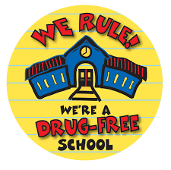 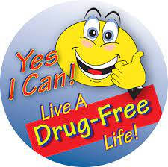

**Friday 07/07/23**

**“DRUGS”**

**“Drug Free – is the way to be”**

**PRIMARY SCHOOL LEVELS**

1. **Short poetry recital** – students to prepare short poems, drawings and display to their classroom
2. **Book markers** –students can collect old buttons, strings and pins to decorate simple book marks with class.
3. **Short skit** – Base on theme, teachers must provide a short plays to their class.
4. **Short song** – student to write a short songs about the theme.
5. **Model Display** – teachers should set model display for their classroom base on the theme.
6. **Narrative Essay (maximum 150 words)** – Teacher can organize oratory competition for students only 80 words base on the theme.
7. **Short Oratory** – Students can prepare short oratory speech during morning talk base on the theme.
8. **Poster Competition** - teachers to organize Poster Competition for students based on the theme
9. **Pledge –** school formulates a “drug-free” pledge, which students read as an oath to be drug –free.
10. **Classroom/bulletin Corner booth display** – teachers can display all charts and student’s work at the Corner Booth and divide the class for the decoration based on the theme.

***(The School Coordinator/HOS – to decide which activity they want to carry on the days)***

**SECONDARY SCHOOL LEVELS**

1. **Poetry recital** – students to prepare poetry based on the theme and have it pasted at their classroom organization board.
2. **Banner Display** – students to prepare banner based on the theme and have it displayed in their own classrooms.
3. **Role-play** - students to prepare role-play based on the theme.
4. **Song** – teachers to organize song competition for students based on the theme.
5. **Model Display** – teachers to organize model display competition for students based on the theme.
6. **Advertisement advocacy (TV/Radio)** – students to prepare TV/Radio Advertisement advocacy based on theme.
7. **Diary Entry (maximum 100 words)** – students to prepare Diary Entry based on theme.
8. **Poster Competition** – teachers to organize Poster Competition for students based on the theme.
9. **School Pledge** – the school writes a creative pledge “TO BE DRUG FREE” – students take this pledge.
10. **Debate –** teachers organize an inter-form debate on “Drug-free is the way to be”.
11. **Panel discussion –** students divided into groups of five – free discussion on “Dangers of drug abuse.”
12. **Classroom/bulletin Corner booth display** - teachers to organize Classroom/Bulletin Corner Booth Display competition for students based on the theme.

***(The School Coordinator/HOS – to decide which activity they want to carry on the days)***

**ADDITIONAL ACTIVITIES TO SUIT THE DAY**

1. **Invite Fiji Police – Narcotics Bureau, Juvenile Bureau, Community Policing, Ministry of Health (Public Health Nurse), Social Welfare, Boarder Control Officers [FIRCA], Legal Aid Commission, Drug Free Fiji, SAAC officers or Faith Based leaders and Education Officers, Social Welfare Department, Education Officers** to address the students on the dangers of drugs in their life.
2. **Invite Drug Survivors to address the students.**
3. **Decision Making Skills** –Helping Primary school students to make right choices in life with regards to drug use.
4. **Rethink your drink** –Tell the students to bring bottle of water / coconut water/fresh natural fruit juiceand remind them that those beverages are healthy for their body.
5. **Student’s activity** – creative posters, debate, banners, bookmark, oratory, panel discussion, display corner promoting a Life Free of Drugs.
6. **Display Red color (optional) –** display **Red** colors on trees, door knobs, fences, desks, tables,etc.

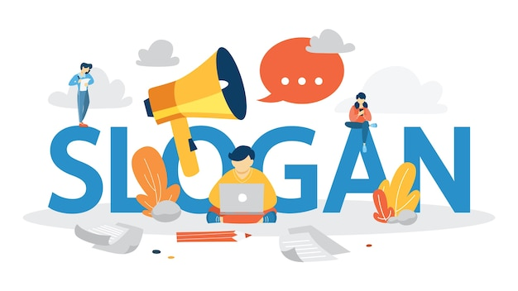

 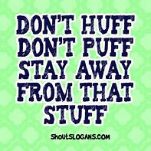 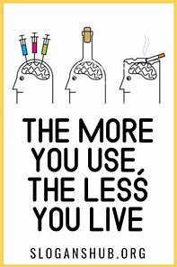

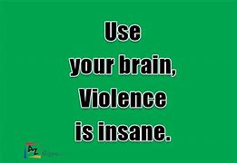 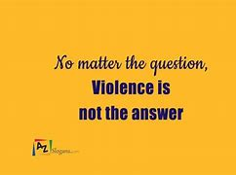 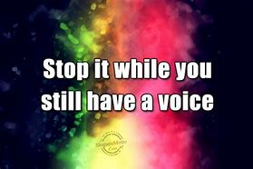

  

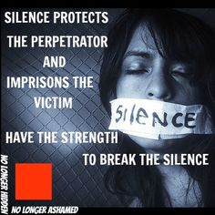 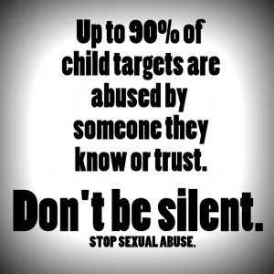 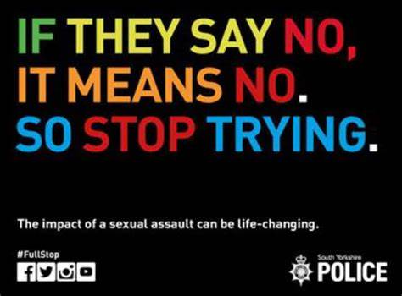

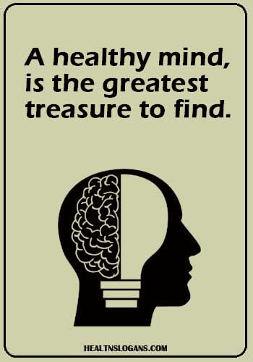 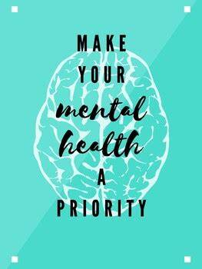 

**ROLL A DICE – GIVE THIS A TRY!!**

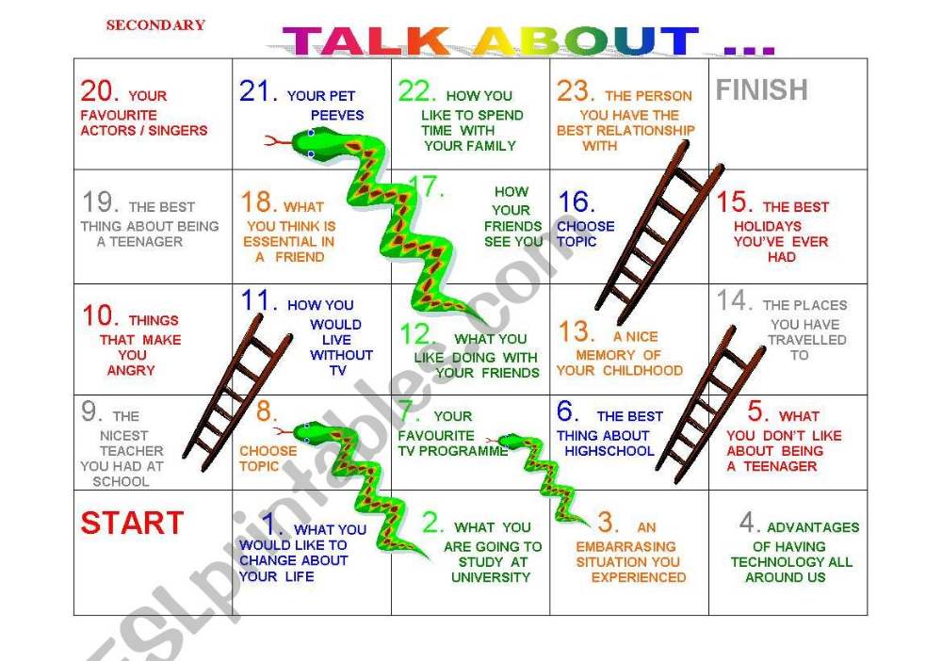

* ***Students feel free to talk about their emotions in front of friends and a teacher****.*

**PRIMARY**

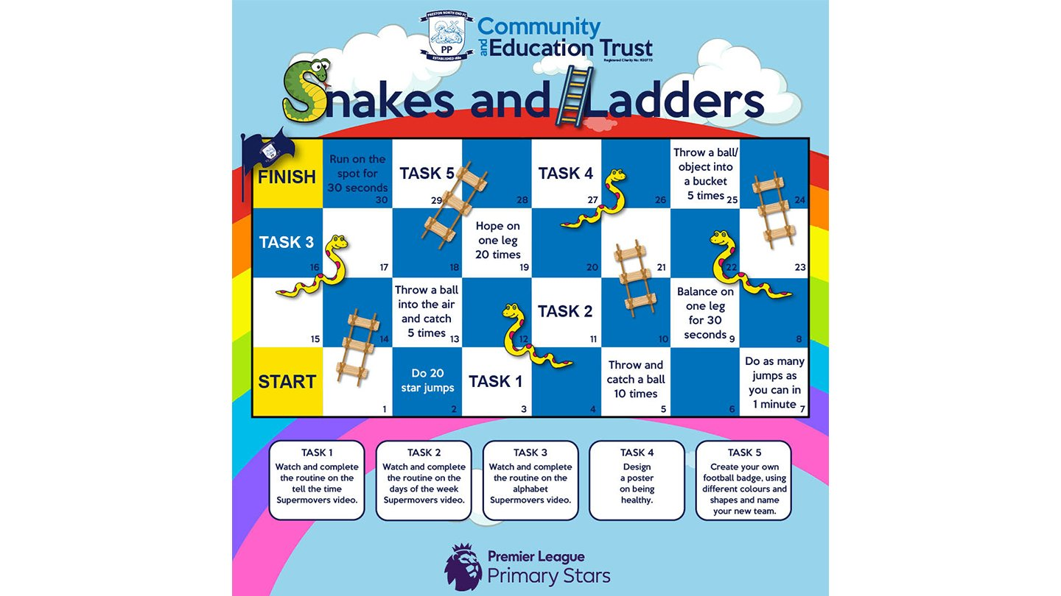

* ***Students feel free to participate in this fun activity under the supervision of a teacher***

**INFORMATION GUIDE – TO CREATE AWARENESS**

* **DRUG USE**

**The use of illegal drugs or the use of prescription or over-the-counter drugs for purposes other than those for which they are meant to be used, or in excessive amounts**.

* **TYPES OF DRUGS**

1. ***Legal Drugs***

Legal drugs are those that are allowed under the law to be consumed. Alcohol, tobacco and kava are allowed under the law. Apart from these, medications pre-scribed by the doctor are also legal drugs.

1. ***Illegal Drugs***

Illegal drugs are drugs that are not allowed to use, cultivate, transport, sell or pro-duce under the law. The maximum penalties can be life imprisonment. Whenever we think or hear of the phrase illegal drugs, images of marijuana and other psychotic and hallucinogenic come across our minds. Methamphetamine, Cocaine, heroin, Cannabis, etc. are some of the popularly known illegal drugs.

* **CATEGORIES OF DRUGS**

1. ***Stimulants***

Stimulants are drugs speed up the central nervous system and brain and produce bursts of Energy. As many people deal with issues that result in fatigue, stress, and sluggishness in their day-to-day routine, stimulants often seem like a viable solution to living an energetic and accomplished life. Stimulants are both prescription and illegal, yet all are addictive.

1. ***Depressants***

Depressants are drugs that help slow the central nervous system and brain. Their desired effects include a sense of relaxation and calming the body and mind. Some drugs are both depressants and narcotics, such as the opiate heroin. While opiates are pain relievers or analgesics, they also have depressant factors. One depressant frequently sold and used worldwide is alcohol.

1. ***Hallucinogen***

Hallucinogens are known for altering mood, sensory awareness, and perception. As hallucinogenic drugs enter the bloodstream and brain, a variety of effects are experienced. Most notable are sensations of being out of the body, having an altered sense of perception, and deeper awareness of surroundings. Hallucinogens provide a sense of perception not based on reality produced through the normal

* **DRUG ABUSE**

Drug abuse is **when you use legal or illegal substances in ways you shouldn't**. You might take more than the regular dose of pills or use someone else's prescription. You may abuse drugs to feel good, ease stress, or avoid reality. But usually, you're able to change your unhealthy habits or stop using altogether.

* **DRUG ADDICTION**

Drug addiction, also called substance use disorder, is a disease that affects a person's brain and behavior and leads to an inability to control the use of a legal or illegal drug or medication. Substances such as alcohol, marijuana and nicotine also are considered drugs. When you're addicted, you may continue using the drug despite the harm it causes.

The risk of addiction and how fast you become addicted varies by drug. Some drugs, such as opioid painkillers, have a higher risk and cause addiction more quickly than others.

As time passes, you may need larger doses of the drug to get high. Soon you may need the drug just to feel good. As your drug use increases, you may find that it's increasingly difficult to go without the drug. Attempts to stop drug use may cause intense cravings and make you feel physically ill (withdrawal symptoms).

***Symptoms***

Drug addiction symptoms or behaviors include, among others:

* Feeling that you have to use the drug regularly — daily or even several times a day
* Having intense urges for the drug that block out any other thoughts
* Over time, needing more of the drug to get the same effect
* Taking larger amounts of the drug over a longer period of time than you intended
* Making certain that you maintain a supply of the drug
* Spending money on the drug, even though you can't afford it
* Not meeting obligations and work responsibilities, or cutting back on social or recreational activities because of drug use
* Continuing to use the drug, even though you know it's causing problems in your life or causing you physical or psychological harm
* Doing things to get the drug that you normally wouldn't do, such as stealing
* Driving or doing other risky activities when you're under the influence of the drug
* Spending a good deal of time getting the drug, using the drug or recovering from the effects of the drug
* Failing in your attempts to stop using the drug
* Experiencing withdrawal symptoms when you attempt to stop taking the drug
* **CAUSES OF USING DRUGS**

Like many other mental and physical health problems, multiple factors can and usually do contribute to drug addiction. The most frequently observed contributing causes of drug addiction include:

* **Genetics.** How your body and brain react to a particular drug is in part determined by your inherited traits, those encoded by your genes. Those traits can speed up or slow down the way the disease of addiction develops.
* **Environment.** Environmental factors, such as your access to healthcare, exposure to a peer group that tolerates or encourages drug abuse, your educational opportunities, the presence of drugs in your home, your beliefs and attitudes, and your family’s use of drugs are factors in the first use of drugs for most people, and whether that use escalates into addiction.
* **CONSEQUENCES OF DRUG ABUSE**

Young people who persistently abuse substances often experience an array of problems, including academic difficulties, health-related problems (including mental health), poor peer relationships, and involvement with the juvenile justice system. Additionally, there are consequences for family members, the community, and the entire society.

* ***Academics***

Declining grades, absenteeism from school and other activities, and increased potential for dropping out of school are problems associated with adolescent substance abuse. Hawkins, Catalano, and Miller (1992) cite research indicating that a low level of commitment to education and higher truancy rates appear to be related to substance use among adolescents. Cognitive and behavioral problems experienced by alcohol- and drug-using youth may interfere with their academic performance and also present obstacles to learning for their classmates (Bureau of Justice Statistics, 1992).

* ***Physical health***

Injuries due to accidents (such as car accidents), physical disabilities and diseases, and the effects of possible overdoses are among the health-related consequences of teenage substance abuse. Disproportionate numbers of youth involved with alcohol and other drugs face an increased risk of death through suicide, homicide, accident, and illness.

* ***Mental health***

Mental health problems such as depression, developmental lags, apathy, withdrawal, and other psychosocial dysfunctions frequently are linked to substance abuse among adolescents. Substance-abusing youth are at higher risk than nonusers for mental health problems, including depression, conduct problems, personality disorders, suicidal thoughts, attempted suicide, and suicide. Marijuana use, which is prevalent among youth, has been shown to interfere with short-term memory, learning, and psychomotor skills. Motivation and psychosexual/emotional development also may be influenced (Bureau of Justice Statistics, 1992).

* ***Peers***

Substance-abusing youth often are alienated from and stigmatized by their peers. Adolescents using alcohol and other drugs also often disengage from school and community activities, depriving their peers and communities of the positive contributions they might otherwise have made.

* ***Families***

In addition to personal adversities, the abuse of alcohol and other drugs by youth may result in family crises and jeopardize many aspects of family life, sometimes resulting in family dysfunction. Both siblings and parents are profoundly affected by alcohol- and drug-involved youth (Nowinski, 1990). Substance abuse can drain a family's financial and emotional resources (Bureau of Justice Statistics, 1992).

* ***Social and economic consequences***

The social and economic costs related to youth substance abuse are high. They result from the financial losses and distress suffered by alcohol- and drug-related crime victims, increased burdens for the support of adolescents and young adults who are not able to become self-supporting, and greater demands for medical and other treatment services for these youth (Gropper, 1985).

* **ADDICTION AS A COPING TECHNIQUE**

As addiction is considered a brain disease with behavioral implications, professional help is optimal in helping to restore a healthy balance to the brain and create new and healthier coping mechanisms. Addiction treatment programs use behavioral therapies, counseling, supportive measures, and often medications to regulate brain chemistry and build new and improved habits and life skills for recovery. Stress and anger management, communication skills, relapse prevention tools, and new coping mechanisms are learned.

During addiction treatment, individuals are taught methods for managing cravings and handling potential triggers that may arise. There are many healthy alternatives to using addiction as a coping mechanism, and these alternatives can be used in recovery to minimize relapse and keep moving forward. They include:

* Exercise: Healthy doses of exercise release endorphins and help to reduce tension, stabilize moods, and improve self-esteem and sleep habits.
* Mindfulness meditation: Yoga, meditation, and mindfulness meditation can be useful as coping mechanisms to bring about self-reflection and make people more in tune with their bodies.
* Spirituality: For many, finding faith and a connection to a higher power can provide an inner strength and strong foundation for managing difficulties as well as for self-introspection.
* Positive reframing: Try to think of things in a positive light instead of a negative one. By thinking of conflicts positively, perspectives can be changed for the better.
* Humor: Humor is considered a healthy coping mechanism, as laughter can help people to see things in a lighter frame of mind.
* Problem-solving: By identifying a problem as it arises, a person can better learn how to handle it and not be overwhelmed by the issue.
* Communication and support: Talk it out, and don’t be afraid to ask for help when needed. Healthy communication can be a great outlet for releasing stress, and it can be helpful to have a support group of peers, therapists, family members, friends, and mentors to lean on and talk to on regular basis.

**REFERENCES**

* <https://your-drug-crime-lawyer.com/drug-trafficking-and-its-many-consequences/#:~:text=The%20penalties%20for%20drug%20trafficking,drugs%2C%20and%20the%20distribution%20area>.
* <https://www.mayoclinic.org/diseases-conditions/drug-addiction/symptoms-causes/syc-20365112>
* <https://www.mind.org.uk/information-support/types-of-mental-health-problems/drugs-recreational-drugs-alcohol/types-of-recreational-drug/>
* <https://blackbearrehab.com/blog/legal-consequences-of-drug-abuse/>
* <https://ojjdp.ojp.gov/sites/g/files/xyckuh176/files/pubs/drugid/ration-03.html>
* <https://summitbhc.com/drug-addiction-consequences/>
* <https://americanaddictioncenters.org/sobriety-guide/coping-mechanism>
* **VIOLENCE**

Violence is "the use of physical force so as to injure, abuse, damage, or destroy". Other definitions are also used, such as the World Health Organization's definition of violence as "the intentional use of physical force or power, threatened or actual, against oneself, another person, or against a group or community, which either results in or has a high likelihood of resulting in injury, death, psychological harm, mal-development, or deprivation."

* **TYPES OF VIOLENCE**

Violence varies by types according to sexual, psychological, physical and economic violence occurring in the family, within the general community, perpetrated or condoned by the state (UNICEF, 2000). The type of violence indicates the means used to impose discipline, or to impose the concept of who is in control.

* **COMMON -TYPES OF VIOLENCE IN SCHOOL**
* **Physical violence**, includes any kind of physical aggression, the use of weapons, as well as criminal acts like theft or arson.
* **Psychological violence**, which comprises [emotional](https://www.verywellmind.com/identify-and-cope-with-emotional-abuse-4156673) and [verbal abuse](https://www.verywellmind.com/how-to-recognize-verbal-abuse-bullying-4154087). This may involve insulting, threatening, ignoring, isolating, rejecting, name-calling, humiliating, ridiculing, rumor-mongering, lying, or punishing another person.
* **Sexual violence**, is sexual harassment, sexual intimidation, unwanted touching, sexual coercion, and [rape](https://www.verywellmind.com/what-is-sexual-assault-4844451).
* **Bullying**, which can take [physical, psychological, or sexual forms](https://www.verywellmind.com/what-are-the-different-types-of-bullying-5207717) and is characterized by repeated and intentional aggression toward another person.
* **Cyberbullying**, looks at sexual or psychological abuse by people connected through school on social media or other online platforms. This may involve posting false information, hurtful comments, malicious rumors, or embarrassing photos or videos online. [Cyberbullying](https://www.verywellmind.com/the-psychology-of-cyberbullying-5086615) can also take the form of excluding someone from online groups or networks.
* **CAUSES OF VIOLENCE**
* The influence of one’s peers
* Having a lack of attention or respect
* Having low self-worth
* Experiencing abuse or neglect
* Witnessing violence in the home, community, or media.
* **IMPLICATIONS OF VIOLENCE**
* Fear
* Anxiety
* Depression
* Injury
* Permanent injury
* Disability
* Mental instability
* More Violence
* **OVERCOMING VIOLENCE**
* Empowering students in anger management strategies through school interventions Program like the Gender Meeting, Mentoring Groups, Level Meeting, Clubs meeting, etc.
* Workshops organized for Teachers and Student Leaders on Proactive measures on minimizing put a stop in violence in erupting in the school/home setting.
* Awareness Programs on the repercussion of Violence should be compulsory in all school Family Life Class.
* Engaging Counsellors to schools and work with the Administration Team to look out for the each student’s welfare and creating policies that will bring out safe environment for students within and outside the school.
* Inviting NGO’S, Police, Social Welfare, and other Agencies to share and create awareness programs in schools to allow the students to be knowledgeable when in come to Putting a Stop to Violence.

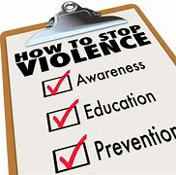 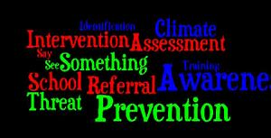

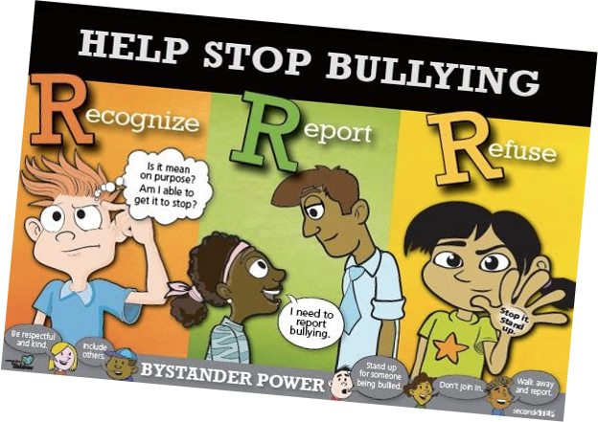

**REFERENCES**

* <http://www.findacriminaldefenseattorney.com/Information-Center/Types-of-Crimes/Sex-Crimes.aspx>
* <https://www.ourresilience.org/what-you-need-to-know/effects-of-sexual-violence>
* <https://www.harleytherapy.co.uk/counselling/causes-of-violence-how-to-respond.htm>
* <https://www.verywellmind.com/school-violence-types-causes-impact-and-prevention-5216631>
* **SOCIAL MEDIA SAFETY**

There are lots of benefits for children and young people when using social media. This includes staying connected with friends and family, enabling innovative ways of learning and creating new ways for them to express themselves.

It can also have many benefits to organizations, for example:

* staying in contact with children outside of face-to-face meetings, activities and events
* providing specialist support to children, such as counselling and therapy
* promoting events
* Live streaming activities and running online sessions.
* Creating online groups, forums and communities.

***But there are risks when you’re using social media to communicate with children.***

#### **ONLINE RISKS**

1. Children may be exposed to upsetting or inappropriate content online, particularly if the platform you’re using doesn’t have robust privacy and security settings or if you’re not checking posts. This content might be sexually explicit or it might be harmful in other ways, such as [bullying](https://learning.nspcc.org.uk/child-abuse-and-neglect/bullying/), or content that's upsetting.
2. Children may be at risk of being [groomed](https://learning.nspcc.org.uk/safeguarding-child-protection/grooming/) if they have an online profile that means they can be contacted privately.
3. Children’s posts or profile information may expose personal information and put them at risk. For example, they may talk about their home life, feelings, or thoughts they’ve been having. There may be information that makes them identifiable such as locations of events they are taking part in or visual clues in photographs. Perpetrators may use this information to groom, abuse or exploit children.
4. Perpetrators of abuse may create fake profiles to try to contact children and young people through the platform you’re using, for example an adult posing as a child. They may also create anonymous accounts and engage in cyberbullying or trolling. People known to a child can also perpetrate abuse.
5. On many platforms, children can be contacted anywhere and at any time through private messaging or notification alerts. This means it’s harder for them to escape from abusive messages or upsetting content that they are tagged in.

* **10 TIPS TO STAY SAFE ON SOCIAL MEDIA**

1. Use a strong password.  The longer it is, the more secure it will be.
2. Use a different password for each of your social media accounts.
3. Set up your security answers.  This option is available for most social media sites.
4. If you have social media apps on your phone, be sure to password protect your device.
5. Be selective with friend requests. If you don’t know the person, don’t accept their request.  It could be a fake account.
6. Click links with caution.  Social media accounts are regularly hacked.  Look out for language or content that does not sound like something your friend would post.
7. Be careful about what you share. Don’t reveal sensitive personal information i.e. : home address, financial information, phone number.  The more you post the easier it is to have your identity stolen.
8. Become familiar with the privacy policies of the social media channels you use and customize your privacy settings to control who sees what.
9. Protect your computer by installing antivirus software to safeguard.  Also ensure that your browser, operating system, and software are kept up to date.
10. Remember to log off when you’re done.

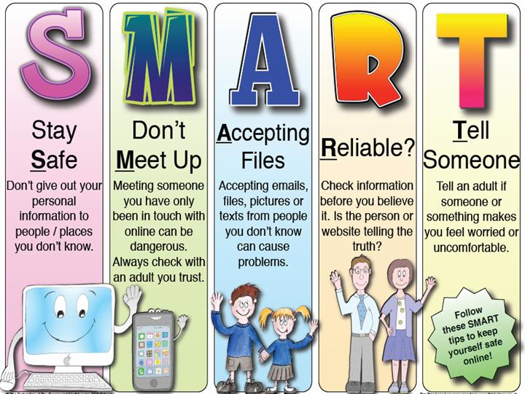

**REFERENCES**

* <https://learning.nspcc.org.uk/safeguarding-child>
* <https://carleton.ca/its/2016/social-media-safety>
* [social media safety FOR SCHOOL STUDENTS - Bing images](https://www.bing.com/images/search?q=social+medisa+safety+FOR+SCHOOL+STUDENTS&form=HDRSC3&first=1)
* **SEX-RELATED OFFENCES**

A sex offense is a class of sexual conduct, which is prohibited by law and usually includes unwanted sexual acts forced on another individual. Sexual offenses vary in type and severity, and cover a wide array of inappropriate behaviors and infractions.

* **TYPES OF SEX-RELATED OFFENCES**
* **Rape**

Rape is generally defined as forced or non-consensual sexual intercourse. There are different types of rape, including statutory rape, spousal rape and date rape. This is one of the most serious sex crimes a person may be accused of committing.

* **Sexual Abuse**

Sexual abuse may be defined as any form of non-consensual contact of a sexual nature. Improper touching, molestation and forced sexual intercourse may fall under this category.

* **Sexual Battery**

Battery is described as unlawful physical contact. When this contact is of a sexual nature, it may be considered sexual battery.

* **Indecent Exposure**

Intentionally exposing oneself in public may be considered the criminal act of indecent exposure.

* **Child Molestation**

Child molestation is a sex offense that may involve a range of indecent sexual conduct involving a child. This usually involves an adult and a child.

* **Child Pornography**

It is illegal to possess, produce or distribute any form of pornographic material depicting minors (individuals under the age of 18). A defendant may face state or federal charges for this type of sex crime.

* **Internet Sex Crimes**

Today, more and more crimes involve the internet and computers. Sex crimes are no exception. Some types of internet sex crimes may include child pornography, luring a minor and committing other sexual offenses on or over the internet.

**COMMON SEX-RELATED OFFENCES IN SCHOOL**

* Sexist name-calling.
* Being sent pictures or video that students did not want to see.
* Rumors about student’s sexual activity being shared.
* Sexual assault of any kind.
* Unwanted touching.

**CAUSES OF SEX-RELATED OFFENCES IN SCHOOL**

* Poor academic performance
* Prior history of violence
* Hyperactive or impulsive personality
* Mental health conditions
* Witnessing or being a victim of violence
* Alcohol, drug, or tobacco use
* Dysfunctional family dynamic
* Domestic violence or abuse
* Delinquent peers
* Poverty or high crime rates in the community

**IMPLICATIONS OF SEX-RELATED OFFENCES IN SCHOOL**

* **Emotional Reactions**
* Guilt, shame, self-blame
* Embarrassment
* Fear, distrust/Sadness
* Vulnerability
* Isolation
* **Psychological reactions**
* Physical reactions
* Nightmares/Flashbacks
* Depression
* Difficulty concentrating
* Post-Traumatic Stress Disorder (PTSD)
* Lack of control
* Anger/Numbness
* Confusion/ Shock, disbelief
* Denial/Anxiety
* Substance use or abuse
* Phobias/Low self esteem

* **Physical injury**
* Concerns about pregnancy or contracting an STI or HIV
* Eating disorders
* Increased startle response
* Concerns about physical safety

**OVERCOMING SEX-RELATED OFFENCES IN SCHOOL**

* **KNOW THE FACTS**

There are a lot of myths about child sexual abuse, so it’s important that you know the facts. The majority of children and teens are most likely to be sexually abused by someone they know and trust. Too often the abuse happens within their own family. This means that school may be one of the only safe places for them, whether you realize it or not. Sexual abuse affects kids of all races, religions, socioeconomic levels, and ages. If you don’t think it’s happening to children who attend your school, you’re wrong. It’s also important for you to know the signs, including looking for the possibility that a child is engaging in harmful sexual behavior and may be at risk for becoming a perpetrator of sexual abuse.

* **LEARN ABOUT AGE-APPROPRIATE SEXUAL DEVELOPMENT**

Depending on the age and maturity of a child, you can be sensitive to patterns of healthy sexual development and what’s typical for students within the age you teach. This may help you recognize sexual abuse, since exhibiting unhealthy or harmful sexual behaviors is a sign the child may have been sexually abused. You can also reduce the risk of a child acting on harmful sexual behaviors if you can recognize the signs. Keep in mind that not all children will develop at the same pace and things like maturity, mental or physical disabilities, and the environment where they’re being raised may impact their development as well.

* **ENCOURAGE EMOTIONAL REGULATION**

There are certain risk factors that raise the possibility of a child being sexually abused. Several of these factors may be combatted if a child learns emotional regulation. Emotional regulation is the ability to respond to the emotions felt in any given situation in a healthy and socially acceptable way. As adults we practice this skill often, but it’s something that children need to practice in order to develop. Responses such as tantrums, shouting, or meltdowns are signals that a child is having difficulty regulating their emotions. Depending on the age of your students you can implement policies in your class to help them have the time and space to work through overwhelming feelings.

* **ENCOURAGE AND SUPPORT SCHOOL POLICIES**

Most schools have policies in place for things like sexual harassment between students as well as policies dictating interactions between teachers and students. Encourage open discussion and understanding of these policies so that everyone (both students and staff) knows and understands both their rights and ways to respect the rights of others.

* **ENCOURAGE PARENTS TO EDUCATE THEIR CHILDREN**

We believe that parents are the most important source of information for their children. Many parents may not be discussing healthy sexual development with their children simply because they don’t realize what an impact it can have. You can encourage them to have little talks about sexual development with their kids.

* **TRUST YOUR INTUITION AND REPORT PROBLEMS**

If you see a coworker or student exhibiting behaviors that cause you to worry, speak up about it. This may be letting a fellow teacher know that their relationship with a student seems to be veering into dangerous territory or pulling a student aside to ask them if everything is okay.

* **BE A TRUSTED ADULT**

There may be kids in your classroom who don’t feel safe at home. No matter what their family looks like, no matter how much (or how little) money their parents make or how nice their neighborhood is, a child may be experiencing sexual abuse. You can create an atmosphere of safety in your classroom and be someone they trust. Let them know that if there are problems in their lives, they can talk to you about them. Stress to them that secrets won’t keep them safe.

**REFERENCES**

* <https://www.instantcheckmate.com/glossary/sexual-offenses>
* [https://www.unescwa.org/sd-glossary/types-violence-abuse#](https://www.unescwa.org/sd-glossary/types-violence-abuse)
* <https://www.verywellmind.com/school-violence-types-causes-impact-and-prevention-5216631>
* <https://apps.who.int/violence-info/youth-violence>
* **MENTAL HEALTH**

Mental health is a state of mind characterized by emotional well-being, good behavioral adjustment, relative freedom from anxiety and disabling symptoms, and a capacity to establish constructive relationships and cope with the ordinary demands and stresses of life.

* **A GOOD MENTAL HEALTH**

Good mental health refers to a state of well-being where an individual experiences happiness, health, and effective functioning in daily life.

* **SIGNS OF GOOD MENTAL HEALTH**
* Experience, express, and regulate a range of emotions
* Recover from hardships
* Deal with uncertainty & change
* Gain and apply knowledge
* Work, reach goals, and realize your potential
* Build and maintain meaningful relationships
* Be aware of your emotions and mood fluctuations
* Set healthy personal boundaries
* Practice self-care and self-love
* Ability to contribute to the community and experience a sense of belonging
* **BENEFITS OF GOOD MENTAL HEALTH**
* Healthier and long-lasting interpersonal relationships
* Better academic and professional success
* A sense of purpose in life
* High self-worth and self-confidence
* Being able to have fun and feeling happy
* A sense of satisfaction and mental peace
* **THE SIGNS AND SYMPTOMS OF POOR MENTAL HEALTH**

### ****Isolation****

If you notice someone canceling on their friends or closing themselves off when it comes to social events, this may be a warning sign. Try to talk to them and find out what’s causing their isolation. Suggest some helplines they can call to help them feel less alone. Very often, people with depression see no point in meeting with anyone, feeling they will only drag others down or that no one wants to be with them. As such, they avoid contact with others as much as possible.

* **Lack of Personal Hygiene**

This is a symptom many people ignore, but it’s one of the most telling ones. If someone with impeccable personal hygiene starts going days without washing their clothes or taking a shower, this should ring a big alarm bell. It means that they can’t motivate themselves to get out of bed even for self-care. Don’t be disgusted or turn away; instead, talk to them to see what’s wrong.

* **Fatigue**

Depression and anxiety bring about sleep issues such as insomnia. Those suffering from anxiety may stay up all night thinking (and overthinking) about everything under the sun. Therefore, once they’re up and about, they may look like they haven’t slept for weeks. If you see someone suffering from fatigue, try to talk to them. Bear in mind that while fatigue may be a symptom of many things, it’s also a symptom of poor mental health.

* **Changing Moods**

Anxiety, anger, moodiness, and other sudden changes in mood can be caused by mental illness. Additionally, reasoning every little thing – such as blaming themselves for small accidents and mistakes – often leads to catastrophizing and thinking about the worst-case scenario. Such thought processes can indicate mental issues.

* **Risky behavior**

Excessive drinking and drug use aren’t always caused by mental illness; however, they can be an important symptom of it. People suffering from poor mental health may look for something to bring meaning to their life – meaning that they believe has been lost forever. They may turn to drugs and alcohol to fill that void. If you notice this kind of destructive behavior, please consider getting them help immediately.

* **Self-harm**

This is one of the most obvious ones and yet it is startling how many people avoid it just because they’re too ashamed to talk about it. People who self-harm are often good at hiding it, but it only takes a more skilled eye to notice. Always take action if you see it, even if you don’t think it’s the right thing to do. You never know when self-harming actions may escalate into something life-threatening.

* **Trouble concentrating**

People who struggle with depression and other mental health conditions exhibit this as a common symptom. It’s because the depressive and anxious thoughts make it difficult for anything else to enter their brain. It’s often overlooked but definitely something to watch out for.

* **Physical symptoms**

It’s commonly thought that mental illness has no physical manifestations, but that’s not true. Anxiety and depression can cause nausea, vomiting, high fever, shivering, and panic attacks. This lowers energy levels and makes it even harder for mental illness sufferers to look after themselves. Keep an eye out for these and don’t just dismiss them as a stomach bug!

* **Running away from responsibilities**

Absence from work or school, failing to call up for appointments or pay bills can all be serious signs of mental illness. It is difficult to find the motivation to do anything when you feel like your life has no meaning – therefore, even necessary responsibilities can be easily overlooked.

* **Social media posts**

This is a symptom unique to the digital era of the internet. People with mental illness often feel that they can voice their feelings online, on Twitter, Instagram, or Facebook, because they feel like no one would be listening. It’s very easy to feel [estranged](https://www.powerofpositivity.com/estranged-from-parents/) on those types of networks and want to desperately reach out to as many people as you can. If you see someone posting worrying things on their social media, don’t just scroll past. It’s very easy to do so, yet sometimes all it takes is a kind word to save someone’s life.

* **HOW TO HAVE GOOD MENTAL HEALTH**

### ****1. Socialize and Connect with People****

Humans are essentially social animals. Numerous studies have attested to the fact that isolation can be bad for mental health. Some ways you can stay connected with people are by:

* Planning meet-ups and video calls
* Using social media from time to time
* Joining clubs and taking part in activities
* Calling/ texting your friends to stay in touch with them

### ****2. Exercise****

Exercise boosts physical health and enhances self-esteem while reducing negative emotions. It is often a supplement to treating mental health conditions such as anxiety disorders and depression.

### ****3. Practice Being Mindful****

One of the best ways to develop good mental health is to pay attention to and live in the present moment. By being more mindful and aware of our thoughts, emotions, and physical sensations, we can be better in touch with ourselves and our environment.

It can help to lift our mood and empower us to experience more positive thoughts and feelings. Mindfulness has been proven to increase subjective well-being, reduce emotional reactivity, and improve behavioral regulation.

### ****4. Follow a Healthy Lifestyle****

Good mental health is closely related to our lifestyle. Certain lifestyle factors play a crucial role in preventing mental disorders. Some of these include:

* Getting adequate sleep
* Eating healthy, nutritious food
* Avoiding alcohol and other substances
* Reducing consumption of excessive trans fats, refined carbs, sugar and caffeine
* Living in a safe environment
* Regularly checking up with a doctor

### ****5. Seek Help****

While ups and downs are a part of life, they can still overwhelm us and make it difficult for us to function in our lives. In such situations, it might be best to speak to a counselor or a therapist, or even join a support group of people who might be suffering from a similar issue.

* **THE IMPORTANCE OF SELF - CARE**

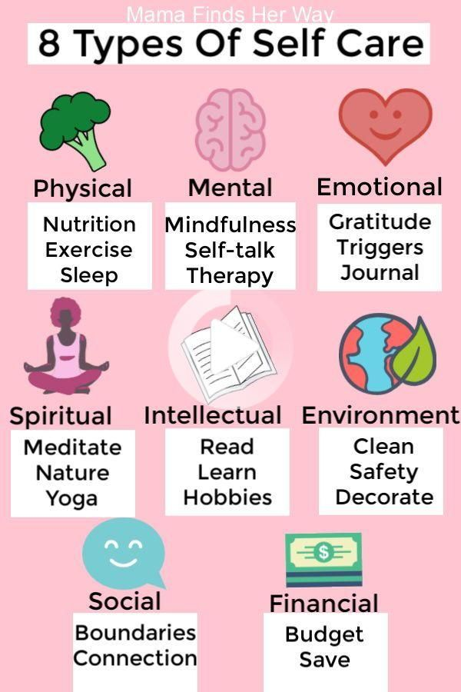

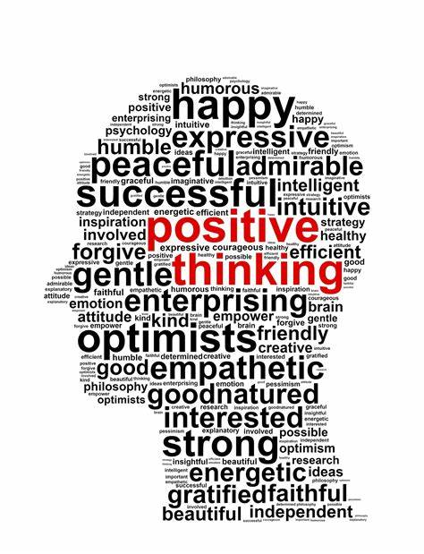

**REFERENCES**

* <https://mind.help/topic/what-is-good-mental-health>
* <https://www.apa.org/topics/mental-health>
* [THE IMPORTANCE OF SELF CARE - Bing images](https://www.bing.com/images/search?view=detailV2&ccid=zCbWdQqh&id=FBF75A3DCFD9BABE3080B2192B8859895B1CED5B&thid=OIP.zCbWdQqhSE2WH9JKcsaW7wHaHa&mediaurl=https%3a%2f%2fpreview.redd.it%2f3egazblvppv31.jpg%3fwidth%3d960%26crop%3dsmart%26auto%3dwebp%26s%3d3283d7eed60bef5e96e3cdcea7915c046f8c3748&cdnurl=https%3a%2f%2fth.bing.com%2fth%2fid%2fR.cc26d6750aa1484d961fd24a72c696ef%3frik%3dW%252b0cW4lZiCsZsg%26pid%3dImgRaw%26r%3d0&exph=960&expw=960&q=THE+IMPORTANCE+OF+SELF+CARE&simid=607990520037978121&FORM=IRPRST&ck=884234565DEBFB9E8D5F285E0FB59351&selectedIndex=19&adlt=strict&ajaxhist=0&ajaxserp=0)
* [POSITIVE THINKING WORDS - Search (bing.com)](https://www.bing.com/search?q=POSITIVE+THINKING+WORDS&FORM=HDRSC1)
* [10 Hidden Signs Of Poor Mental Health to Never Ignore » (powerofpositivity.com)](https://www.powerofpositivity.com/10-hidden-signs-of-poor-mental-health-to-never-ignore/)
* **LIFESTYLE RELATED DISEASES**
* **EFFECT OF SUGAR**

Sugar (including those found in refined carbohydrates) leads to higher amounts of “bad” cholesterol versus the “good” type. Excess amounts of sugar in the bloodstream are converted to fat causing fat storage especially around the abdomen. Fat stored in this area is more conducive to cardiovascular disease.

Imbalanced gut bacteria has far reaching impacts to our health as we now know so much how bacterial species contribute to disease including autoimmunity, obesity, and mental health. And of course, too much sugar is a major driver of insulin resistance and Type 2 Diabetes.

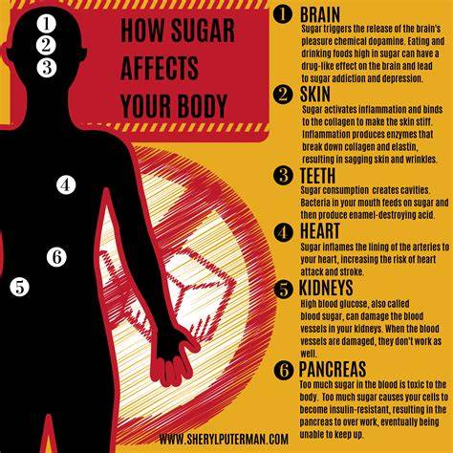

## **PROCESSED FAT**

Processed fats and cheaper vegetable oils used in cooking tend to be damaged easily by heat, processing, and exposure to light. This means that they create harmful free radicals in the body (liken this to a piece of apple that quickly turns brown in the light) that damage our cells and our arteries and increase inflammation.

It’s important to differentiate between these types of fats and the essential fats found in oily fish, nuts and seed and the good fats found in avocados and olive oil. Even a little bit of saturated fat from animal products is significantly better for you than any processed fats or those from cheap vegetable oils.

An excessive amount of oil can cause digestive problems like**stomach pain, bloating, diarrhea, nausea**. Weight gain: Oily food have a high amount of calories that can cause weight gain. The more greasy food you contain, the more your calories count will be.

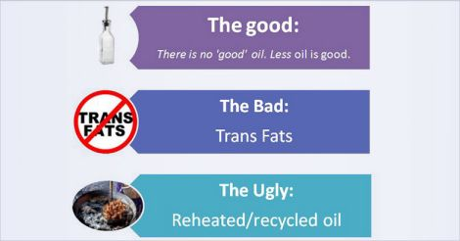

## **SALT**

Salt is one of our electrolytes which is important to body function (such as muscle function and nerve impulses), however too much may contribute to high blood pressure which increases your risk of developing cardiovascular disease – processed foods tend to have higher levels of salt (sodium chloride).

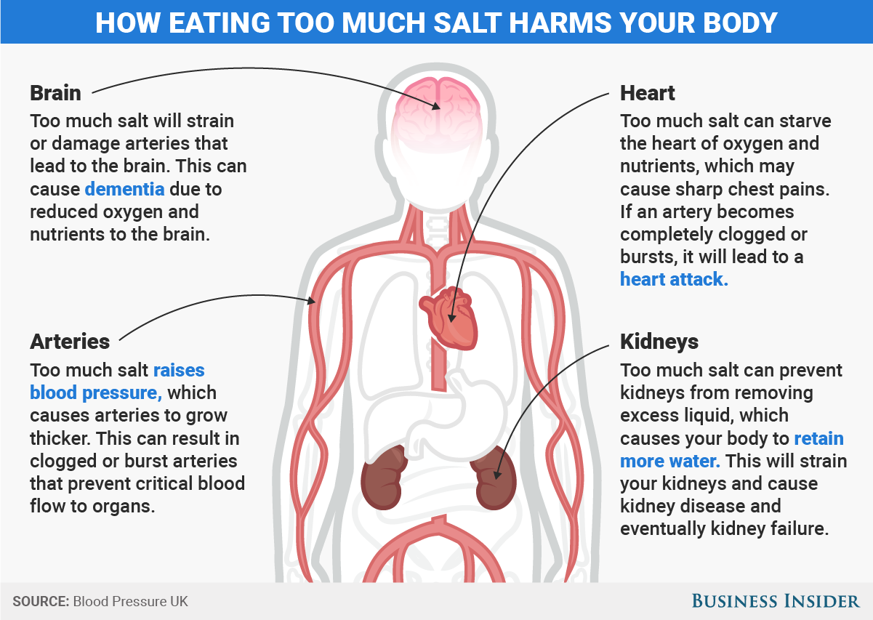

**REFERENCES**

* [How Excess Sugar, Salt & Fat Consumption Impact Health | Peyton Principles](https://www.peytonprinciples.com/blog/how-excess-sugar-salt-fat-consumption-impact-health/)
* [LIST OF BAD EFFECTS OF SUGAR ON BODY - Bing images](https://www.bing.com/images/search?q=LIST+OF+BAD+EFFECTS+OF+SUGAR+ON+BODY&form=HDRSC3&first=1)
* [HOW EATING TOO MUCH OIL AFFECTS YPOUR BODY - Search (bing.com)](https://www.bing.com/search?q=HOW+EATING+TOO+MUCH+OIL+AFFECTS+YPOUR+BODY&FORM=HDRSC1)
* **HEALTHY LIFESTYLE TO BE PROMOTED IN SCHOOL**

### Encouragement of meditations for students

Among the ways of promoting health and wellness in schools, meditation is an essential tool that is needed for the relaxing of the mind and body. There are many benefits accruing from meditation to the wellness of a student not limited to the above-mentioned.

### Get the students engaged

Extracurricular activities should be facilitated in schools for students to engage in. These activities may be in form of fundraising, sports, and other activities that facilitate social interaction and independence. This will help drive the mind away from negativity.

### Make the school environment conducive

A welcoming environment should be open for the students and conducive to learning new things. The environment has a lot to do with the way students see things. A welcoming environment that will encourage extracurricular activities.

### Give students room for voluntary activities

This creates a sense of independence and promotes individual skill-building. It is also an outstanding approach towards promoting health and wellness in schools. Voluntary activities can be organized by the school or other organizations that encourage self-less and courageous involvement in the love of humanity.

### Healthy diets should be encouraged

Eat healthy, live healthy. Good nutrition help improve the academic performance, behavior, and general wellbeing of an individual.

A nutritious meal is to be encouraged and good eating habits cultured. This implies that a good diet can make you stay away from diseases and also improve your mental growth and health.

School policies supporting healthy eating are an important component of school efforts to promote health and wellness in schools.

### Ease in accessing health services

When the health care support assessment is easy, that will promote a better edge in tackling the health care issues faced by students in varying degrees, however, this will also lead to quick detection of an ailment and facilitate fast intervention.

### Encouragement of routine wellness plan

Campaigns should be organized routinely for awareness and engagement for students. This routine wellness plan will help in promoting health and wellness in schools by making them work effectively in teams and develop leadership skills.

### Let the opinions of students count

The opinions of the students should be appreciated and this will give them a sense of belonging and importance as such promoting health and wellness in schools. Give the students voice as such making decisions and laying down guidelines.

### Good policies

A good policy is a tool that helps in uplifting morals amongst students and also encourages respect for one another. Strong school wellness policies can help schools achieve their health and wellness goals easily.

### Resilience building programs

Resilience is the ability to withstand and thrive when faced with negative events, challenges, or adversity. It is a skill that can be developed through the above-listed approaches in promoting health and wellness in schools.

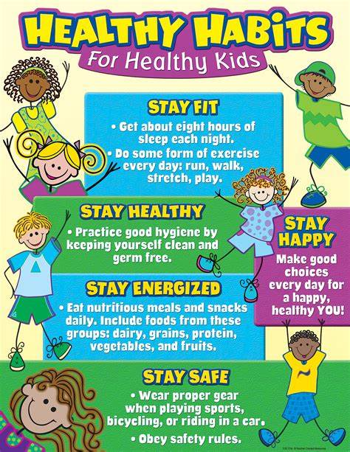

**REFERENCES**

* [Best ways of promoting health and wellness in schools for 2023 - idealmedhealth](https://idealmedhealth.com/promoting-health-and-wellness-in-schools/)
* [ways to promote HEALTHY LIFESTYLE IN SCHOOL - Bing images](https://www.bing.com/images/search?view=detailV2&ccid=p9PmJ37w&id=11F54EE87744C8EFA427D6FD30730D2212FA1800&thid=OIP.p9PmJ37wGwxuvfCs_TcgrwHaJl&mediaurl=https%3a%2f%2fi.pinimg.com%2foriginals%2ff4%2faa%2fd6%2ff4aad655ad8bdcaef6dcdb95fe78d5b8.png&cdnurl=https%3a%2f%2fth.bing.com%2fth%2fid%2fR.a7d3e6277ef01b0c6ebdf0acfd3720af%3frik%3dABj6EiINczD91g%26pid%3dImgRaw%26r%3d0&exph=2000&expw=1545&q=%ef%81%b6%09ways+to+romote+HEALTHY+LIFESTYLE++IN+SCHOOL+&simid=607999208741361136&FORM=IRPRST&ck=FFC0E01BE1C4A93CA465235C77579F3E&selectedIndex=2&adlt=strict&ajaxhist=0&ajaxserp=0)

**OFFICE OF THE DIRECTOR PUBLIC PROSECUTION 2020 DATA**

**ODPP Rape and Sexual Offences Statistics from January to March 2023**

January

|  |  |  |  |
| --- | --- | --- | --- |
| **Total Charged** | **Total of 18 yrs. below Charged and victims** | **Number of 18 yrs. below victim** | **Number of 18 yrs. below charged** |
| 20 | 18 | 5 | 15 |

February

|  |  |  |  |
| --- | --- | --- | --- |
| **Total Charged** | **Total of 18 yrs. below Charged and victims** | **Number of 18 yrs. below victim** | **Number of 18 yrs. below charged** |
| 24 | 24 | 6 | 18 |

March

|  |  |  |  |
| --- | --- | --- | --- |
| **Total Charged** | **Total of 18 yrs. below Charged and victims** | **Number of 18 yrs. below victim** | **Number of 18 yrs. below charged** |
| 17 | 17 | 3 | 14 |

**2020 Total Offences Children age 18 below**

|  |  |  |  |
| --- | --- | --- | --- |
| Month | Total Charged | Total Charged for 18yrs below (1-18yrs) | Under 18 years (1-17yrs) |
| JAN | 20 | 18 | 18 |
| FEB | 24 | 24 | 24 |
| MAR | 17 | 17 | 17 |
| **Total** | **61** | **59** | **59** |

According to the ODPP stats that was provided in their website, the data recorded on the table is under 18 years which only range from 1-17yrs. The data above is for 18 years below that is the range from 1-18yrs.

The offences are rape, attempted rape, sexual assault, defilement and indecently annoying.

**THE FIJI POLICE FORCE 2021 – APRIL 2023 DATA**

**REGISTERED CASES ON SEXUAL CRIME RELATING CHILDREN**

**Table 1 Sexual Offences against Children [2021-2023]**

|  |  |  |  |  |  |  |  |  |  |  |  |  |  |
| --- | --- | --- | --- | --- | --- | --- | --- | --- | --- | --- | --- | --- | --- |
| **Sexual Offences** | **2021** | | | | **2022** | | | | **Jan-April 2023** | | | |  |
| **5 & Below** | **6 yrs - 12 yrs** | **13yrs - 17yrs** | **Total** | **5 & Below** | **6 yrs - 12 yrs** | **13yrs - 17yrs** | **Total** | **5 & Below** | **6yrs - 12yrs** | **13yrs - 17yrs** | **Total** | |
| Rape | 10 | 51 | 154 | 215 | 19 | 77 | 206 | 302 | 4 | 14 | 56 | 74 | |
| Indecent assault | 4 | 37 | 87 | 128 | 2 | 55 | 127 | 184 | 0 | 16 | 27 | 43 | |
| Defilement of young person between 13 and 16 years of age | 0 | 0 | 160 | 160 | 0 | 0 | 160 | 160 | 0 | 0 | 36 | 36 | |
| Sexual assaults | 5 | 39 | 39 | 83 | 12 | 54 | 119 | 185 | 2 | 20 | 28 | 50 | |
| Abduction of person under 18 years of age with intent to have carnal knowledge | 0 | 4 | 74 | 78 | 0 | 1 | 115 | 116 | 0 | 2 | 19 | 21 | |
| Indecently insulting or annoying any person | 3 | 17 | 34 | 54 | 0 | 23 | 34 | 57 | 0 | 4 | 11 | 15 | |
| Attempt to commit rape | 3 | 2 | 4 | 9 | 1 | 9 | 15 | 25 | 0 | 0 | 1 | 1 | |
| Defilement of children under 13 years of age | 0 | 0 | 0 | 0 | 0 | 2 | 0 | 2 | 0 | 1 | 1 | 2 | |
| Assault with intent to commit rape | 0 | 0 | 0 | 0 | 0 | 0 | 2 | 2 | 0 | 0 | 0 | 0 | |
| Defilement of intellectually impaired person | 0 | 0 | 0 | 0 | 0 | 0 | 0 | 0 | 0 | 0 | 1 | 1 | |
| Unnatural offence with animals |  |  | 1 | 1 | 0 | 0 | 1 | 1 | 0 | 0 | 0 | 0 | |
| **Grand Total** | **25** | **150** | **553** | **728** | **34** | **221** | **779** | **1034** | **6** | **57** | **180** | **243** | |

The table above hows the number of sexual offences committed against children in Fiji for the years 2021, 2022, and January-April 2023. The table is broken down by age group, with categories ranging from 5 years old and below, 6-12 years old, and 13-17 years old.

In 2021, a total of 728 sexual-related cases were committed against children, with the majority of the victims falling in the 13-17 age group. The highest number of reported cases was for the offence of rape, with a total of 215 cases reported. The next highest offence category was defilement of young persons between 13 and 16 years old, with a total of 160 cases reported.

In 2022, the total number of reported sexual offence cases increased to 1034, with the highest number of reported cases again being for the offence of rape, with a total of 302 cases reported. The next highest offence category was indecent assault, with 127 cases reported in the 13-17 age group.

For January-April 2023, a total of 243 sexual –related cases were reported, with the majority of the victims falling in the 13-17 age group. The highest number of reported cases was again for the offence of rape, with 74 cases reported. The next highest offence category was indecent assault, with 27 cases reported in the 13-17 age group.

Overall, the data shows that sexual offences against children are still a major problem in Fiji. The majority of the victims are in the 13-17 age group, but there are also cases of sexual offences against children as young as 3 month old. These numbers highlight the need for continued efforts to protect children from sexual violence and to provide support to victims and their families.

**Table 2 Child victims by Gender [2021-2023]**

|  |  |  |  |  |  |  |  |  |  |
| --- | --- | --- | --- | --- | --- | --- | --- | --- | --- |
| **Child Victims by Gender** | **2021** | | | **2022** | | | **Jan-Apr 2023** | | |
| **Sexual Offence** | **Female** | **Male** | **Total** | **Female** | **Male** | **Total** | **Female** | **Male** | **Total** |
| Rape | 202 | 13 | **215** | 287 | 15 | **302** | 69 | 5 | **74** |
| Indecent assault | 124 | 4 | **128** | 154 | 30 | **184** | 41 | 2 | **43** |
| Defilement of young person between 13 and 16 years of age | 160 | 0 | **160** | 150 | 10 | **160** | 34 | 0 | **34** |
| Sexual assaults | 70 | 13 | **83** | 134 | 51 | **185** | 41 | 9 | **50** |
| Abduction of person under 18 years of age with intent to have carnal knowledge | 77 | 1 | **78** | 111 | 5 | **116** | 21 | 0 | **21** |
| Indecently insulting or annoying any person | 54 | 0 | **54** | 53 | 4 | **57** | 14 | 1 | **15** |
| Attempt to commit rape | 6 | 3 | **9** | 19 | 6 | **25** | 1 | 0 | **1** |
| Defilement of children under 13 years of age | 0 | 0 | **0** | 2 | 0 | **2** | 2 | 0 | **2** |
| Defilement of young persons between 13 and 16 years of age | 0 | 0 | **0** | 0 | 0 | **0** | 2 | 0 | **2** |
| Assault with intent to commit rape | 0 | 0 | **0** | 2 | 0 | **2** | 0 | 0 | **0** |
| Defilement of intellectually impaired person | 0 | 0 | **0** | 0 | 0 | **0** | 0 | 1 | **1** |
| Unnatural offences with animals | 0 | 0 | **0** | 0 | 1 | **1** | 0 | 0 | **0** |
| Unnatural offence with animals | 0 | 1 | **1** | 0 | 0 | **0** | 0 | 0 | **0** |
| **Grand Total** | **693** | **35** | **728** | **912** | **122** | **1034** | **225** | **18** | **243** |

The table above provides data on the gender of child victims of sexual offences in Fiji for the years 2021, 2022, and January-April 2023.

The data indicates that in 2021, out of a total of 215 reported cases of rape, 202 victims were female and 13 were male. In 2022, out of a total of 302 reported cases of rape, 287 victims were female and 15 were male. In January-April 2023, out of a total of 74 reported cases of rape, 69 victims were female and 5 were male.

For indecent assault, the data shows that in 2021, out of a total of 128 reported cases, 124 victims were female and 4 were male.

In 2022, out of a total of 184 reported cases, 154 victims were female and 30 were male. In January-April 2023, out of a total of 43 reported cases, 41 victims were female and 2 were male.

Regarding the defilement of young persons between 13 and 16 years of age, the data shows that in 2021, all 160 victims were female. In 2022, out of a total of 160 reported cases, 150 victims were female and 10 were male. In January-April 2023, out of a total of 34 reported cases, all victims were female.

For sexual assaults, the data indicates that in 2021, out of a total of 83 reported cases, 70 victims were female and 13 were male. In 2022, out of a total of 185 reported cases, 134 victims were female and 51 were male. In January-April 2023, out of a total of 50 reported cases, 41 victims were female and 9 were male.

The data also reveals that for the abduction of a person under 18 years of age with intent to have carnal knowledge, in 2021, out of a total of 78 reported cases, 77 victims were female and 1 was male. In 2022, out of a total of 116 reported cases, 111 victims were female and 5 were male. In January-April 2023, out of a total of 21 reported cases, all victims were female.

Overall, the data shows that female children are disproportionately affected by sexual offences in Fiji. In 2021, out of a total of 728 reported cases, 693 victims were female and 35 were male. In 2022, out of a total of 1,034 reported cases, 912 victims were female and 122 were male. In January-April 2023, out of a total of 243 reported cases, 225 victims were female and 18 were male.

**REGISTERED CASES ON PHYSICAL CRIME RELATING CHILDREN**

**Table 3 Assault-related Offences against Children**

|  |  |  |  |  |  |  |  |  |  |  |  |  |
| --- | --- | --- | --- | --- | --- | --- | --- | --- | --- | --- | --- | --- |
| **Physical abuse against Children** | **2021** | | | | **2022** | | | | **Jan-Apr 2023** | | | |
| **Assault-related Offences** | **5 & Below** | **6yrs - 12yrs** | **13yrs - 17yrs** | **Total** | **5 & Below** | **6yrs - 12yrs** | **13yrs - 17yrs** | **Total** | **5 & Below** | **6yrs - 12yrs** | **13yrs - 17yrs** | **Total** |
| Assault causing actual bodily harm | 20 | 119 | 240 | **379** | 19 | 141 | 242 | **402** | 9 | 29 | 73 | **111** |
| Common assault | 4 | 28 | 75 | **107** | 7 | 28 | 54 | **89** | 0 | 8 | 10 | **18** |
| Acts intended to cause grievous harm | 0 | 4 | 6 | **10** | 2 | 3 | 5 | **10** | 0 | 0 | 1 | **1** |
| Unlawful wounding | 0 | 1 | 1 | **2** | 0 | 3 | 5 | **8** | 0 | 0 | 1 | **1** |
| Grievous harm | 0 | 3 | 0 | **3** | 0 | 3 | 0 | **3** | 0 | 0 | 0 | **0** |
| Wrongful confinement | 0 | 0 | 2 | **2** | 0 | 0 | 1 | **1** | 0 | 0 | 0 | **0** |
| Murder | 0 | 0 | 2 | **2** | 0 | 0 | 1 | **1** | 0 | 0 | 0 | **0** |
| Attempted murder | 1 | 0 | 0 | **1** | 1 | 0 | 0 | **1** | 0 | 0 | 0 | **0** |
| Serious assaults | 0 | 0 | 0 | **0** | 0 | 0 | 2 | **2** | 0 | 0 | 0 | **0** |
| Manslaughter | 0 | 1 | 0 | **1** | 1 | 0 | 0 | **1** | 0 | 0 | 0 | **0** |
| Reckless and negligent acts | 0 | 0 | 0 | **0** | 0 | 0 | 0 | **0** | 1 | 0 | 0 | **1** |
| Acts intended to cause grievous harm or prevent arrest | 0 | 0 | 0 | **0** | 0 | 0 | 0 | **0** | 0 | 0 | 1 | **1** |
| Kidnapping | 1 | 0 | 0 | **1** | 0 | 0 | 0 | **0** | 0 | 0 | 0 | **0** |
| Manslaughter arising from a breach of duty | 0 | 0 | 0 | **0** | 1 | 0 | 0 | **1** | 0 | 0 | 0 | **0** |
| **Grand Total** | **26** | **156** | **326** | **508** | **31** | **178** | **310** | **519** | **10** | **37** | **86** | **133** |

The table above shows the number of physical abuse cases against children in three consecutive years: 2021, 2022, and 2023. The data is categorized based on assault-related offences against children of different age groups.

I

n 2021, there were a total of 508 cases of physical abuse against children, with 326 cases involving children between the ages of 13 and 17, 156 cases involving children between the ages of 6 and 12, and 26 cases involving children 5 years old and below. The most prevalent offence was assault causing actual bodily harm, with 379 cases reported. Other offences included common assault, acts intended to cause grievous harm, and unlawful wounding.

In 2022, the total number of physical abuse cases increased to 519, with the highest number of offences again being assault causing actual bodily harm, with 402 cases. The age group most affected by these cases remained the same, with 310 cases involving children between the ages of 13 and 17, 178 cases involving children between the ages of 6 and 12, and 31 cases involving children 5 years old and below.

In 2023, the total number of physical abuse cases recorded was 133, with the highest number of offences being assault causing actual bodily harm, with 111 cases.

It is essential to acknowledge that any form of physical abuse against children is unacceptable and can have severe and long-term impacts on the child's health and well-being. Parents, caregivers, and society at large must work together to ensure the safety and protection of children from all forms of abuse.

**DRUGS ISSUES [REGISTERED CASES]**

**Table 4 Drugs cases involving Juveniles [2021-2023]**

|  |  |  |  |
| --- | --- | --- | --- |
| **Offenders by Age group** | **2021** | **2022** | **Jan-Apr 2023** |
| 14 years | 0 | 1 | 0 |
| 15yrs | 1 | 8 | 0 |
| 16yrs | 4 | 10 | 4 |
| 17yrs | 13 | 20 | 7 |
| **Grand Total** | **18** | **39** | **11** |

The table shows the number of juvenile offenders involved in drug-related cases from 2021 to April 2023. The data is grouped by age, with the youngest offender being 14 years old and the oldest being 17 years old.

In 2021, there were 18 reported cases of juveniles involved in drug offenses. Among these cases, four were 16-year-olds, 13 were 17-year-olds, and one was 15 years old. In 2022, the number of cases increased to 39, with the majority of offenders being 17 years old (20 cases), followed by 16-year-olds (10 cases) and 15-year-olds (8 cases). In the first four months of 2023, there were 11 cases reported, with four involving 16-year-olds, seven involving 17-year-olds, and none involving 14 or 15-year-olds.

The data suggests an upward trend in the number of juvenile offenders involved in drug offences over the years. It is concerning that the majority of these cases involve 16 and 17-year-olds, who are on the verge of adulthood. These statistics highlight the need for a more proactive approach to prevent drug abuse and addiction among young people, including education and access to counseling services.

**THEFT OFFENCES [REGISTERED CASES]**

**Table 5 Theft offence committing by Juveniles**

|  |  |  |  |
| --- | --- | --- | --- |
| Offenders by age group (YRS) | 2021 | 2022 | Jan-Apr 2023 |
| 11 | 0 | 1 | 0 |
| 12 | 0 | 1 | 0 |
| 13 | 4 | 1 | 0 |
| 14 | 2 | 10 | 4 |
| 15 | 17 | 21 | 7 |
| 16 | 26 | 47 | 13 |
| 17 | 79 | 81 | 16 |
| Total | **128** | **162** | **40** |

Table 5 shows the number of theft offences committed by juveniles in Fiji between 2021 and January to April 2023. The data is categorized by age group, with offenders ranging from 11 to 17 years old. In 2021, there were 128 recorded cases of theft offences committed by juveniles.

This number increased to 162 in 2022. Offenders who were 17 years old accounted for the highest number of offences committed, with 79 in 2021, 81 in 2022, and 16 between January to April 2023. The number of offences committed by offenders aged 16 and 15 also remained high throughout the three-year period.

On the other hand, the number of offenses committed by offenders aged 14 and below decreased significantly in 2023. The most commonly stolen items in general include cash, electronics (such as laptops and smartphones), jewelry, clothing, and food items.

**SOCIAL ISSUES RELATING CHILDREN**

**Table 6 Suicide & Attempted Suicide cases amongst Children [2021-20th April 2023]**

|  |  |  |  |  |  |  |  |  |  |  |  |
| --- | --- | --- | --- | --- | --- | --- | --- | --- | --- | --- | --- |
| **Year** | **Victims Age group** | **Hanging** | | **Other Chemicals** | | **Tablet** | | **Burns** | | **Total** | |
| **Suicide** | **Att/Suicide** | **Suicide** | **Att/Suicide** | **Suicide** | **Att/Suicide** | **Suicide** | **Att/Suicide** | **Suicide** | **Att/Suicide** |
| 2021 | 6-12 | 2 | 1 | 0 | 0 | 0 | 1 | 0 | 0 | **2** | **2** |
| 13-17 | 3 | 1 | 0 | 12 | 0 | 6 | 0 | 0 | **3** | **19** |
| 2022 | 5 & Below | 0 | 0 | 0 | 2 | 0 | 0 | 0 | 0 | **0** | **2** |
| 13-17 | 5 | 2 | 0 | 9 | 0 | 2 | 1 | 0 | **6** | **13** |
| 2023 | 13-17 | 4 | 1 | 0 | 1 | 0 | 1 | 0 | 0 | **4** | **3** |
|  | **Total** | **14** | **5** | **0** | **24** | **0** | **10** | **1** | **0** | **15** | **39** |

Table 6 provides information on the number of suicide and attempted suicide cases among children over a period of three years - 2021, 2022, and 2023.

The table is divided into columns that represent the year, the age group of the victims, and the methods used for suicide and attempted suicide. T

The methods listed in the table are hanging, other chemicals, tablets, and burns. There were a total of 54 cases of suicide and attempted suicide among children aged 5-17 years. Out of these cases, hanging was the most common method of suicide, accounting for 14 case

**Contact Lists**

|  |  |  |  |  |  |  |  |  |
| --- | --- | --- | --- | --- | --- | --- | --- | --- |
| MENTAL HEALTH | |  |  | FIJI POLICE FORCE | | | |  |
| Suva St Giles Hospital | 3381399 |  |  | Fiji Police Emergency |  | 917 | |  |
| Stress management Ward | 3313444 |  |  | Fiji Police Information |  | 919 | |  |
| Community Mental |  |  |  | POLICE HEADQUARTERS |  |  |  |  |
| Health Team | 3215051 |  |  |  |  |  | Suva - 3343777 |  |
| Public Health Nurse | 330 6177 |  |  | CID HEADQUARTERS |  |  | 3315999 |  |
| Adolescent Health | Suva – 3319078 |  |  | Totogo Police Station |  | 3311222 | |  |
| Development | Lautoka – 6640243 |  |  |  |  |  |  |  |
|  | Labasa - 8812522 |  |  |  |  |  |  |  |
| STI Clinic | Suva - 3319144 |  |  | SOUTHERN DIVISION |  | 3372524 | |  |
| EMPOWER PACIFIC | |  |  | Nabua Police Station |  | 3384000 | |  |
| Lautoka | 6650482/7769224 |  |  | Navua Police Staion |  | 3460222 | |  |
| Mobile | 8318515 |  |  | Lami Police Station |  | 3361222 | |  |
| Suva | 7780015 |  |  | Samabula Police Station |  | 3381222 | |  |
| Labasa | 7760017 |  |  | Raiwaqa Police Station |  | 3383222 | |  |
| Nadi | 7760018 |  |  | Valelevu Police Station |  | 3393222 | |  |
| SOCIAL WELFARE DEPARTMENT | |  |  | Nasinu Police Station |  | 3392222 | |  |
| CHILD HELP LINE | 1325 |  |  | Kadavu Police Station |  | 3681268 | |  |
| Suva | 3315585 |  |  | Vanuabalavu Police Station |  | 8280890 | |  |
| Ba | 6674245 |  |  | Lakeba Police Station |  | 8280999 | |  |
| Lautoka | 6660241 |  |  | Moala Police Station |  | 6030307 | |  |
| Nausori | 3478361 |  |  | Rotuma Police Station |  | 8891222 | |  |
| Nasinu | 3683395 |  |  | WESTERN DIVISION |  |  | 6662222 |  |
| Nabouwalu | 8836166 |  |  | Lautoka Police Station |  | 6660222 | |  |
| Nadi | 6700430 |  |  | Ba Police Station |  | 6674222 | |  |
| Rakiraki | 6694432 |  |  | Nadi Police Station |  | 6700222 | |  |
| Savusavu | 8850365 |  |  | Namaka Police Station |  | 6722222 | |  |
| Sigatoka | 6500127 |  |  | Sabeto Police Station |  | 6722285 | |  |
| Taveuni | 8881469 |  |  | Rakiraki Police Station |  | 6694222 | |  |
| Vunidawa | 3683093 |  |  | Nalawa Police Station |  | 6280005 | |  |
| FIJI WOMEN’S CRISIS CENTRE | |  |  | Sigatoka Police Station |  | 6500222 | |  |
| Suva | 3313300/9209470 |  |  | Navosa Police Station |  | 6280862 | |  |
|  |  |  |  |  |  |
| Nadi | 6707558/7404760 |  |  | Tavua Police Station |  | 6680222 | |  |
|  |  |  |  |  |  |
| Labasa | 8816609/9377784 |  |  | Vatukoula Police Station |  | 6681575 | |  |
|  |  |  |  |  |  |
| Ba | 6670466/9239775 |  |  | EASTERN DIVISION |  |  | 3477589 |  |
|  |  |  |  |  |  |  | |  |
| Ra | 6694012/9129790 |  |  | Nausori Police Station |  | 3477222 | |  |
|  |  |  |  |  |  |  | |  |
| MEDICAL SERVICES PACIFIC | |  |  | Nakasi Police Station |  | 3410722 | |  |
| Suva Office | 3315295 |  |  | Vunidawa Police Station |  | 3685392 | |  |
|  |  |  |  |  |  |  | |  |
| Suva Clinic | 4502907 |  |  | Korovou Police Station |  | 3430222 | |  |
|  |  |  |  |  |  |  |  |
|  | 3310865/8387332 |  |  | Levuka Police Station |  | 3440222 | |  |
|  |  |  |  |  |  |  | |  |
| Labasa Office | 8811308 |  |  | Koro Police Station |  | 3681002 | |  |
|  |  |  |  |  |  |  |  |  |
| Labasa Clinic | 8280308 |  |  |  |  |  |  |  |
|  |  | NORTHERN DIVISION |  |  | 8811222 |  |
|  |  |  |  |  |  |  |
| Lautoka Hope Centre | 6640243 |  |  | Labasa Police Station |  | 8811222 | |  |
| Lifeline Fiji Crisis Line | 132454 [24/7] |  |  | Seaqaqa Police Station |  | 8860222 | |  |
| Fiji Women’s Right |  |  |  |  |  |  |  |  |
| Movement | 3313156 |  |  | Savusavu Police Station |  | 8850222 | |  |
| Youth Champs for Mental | 8620146 |  |  |  |  |  |  |  |
| Health |  |  |  | Tukavesi Police Station |  | 8283045 | |  |

|  |  |  |  |  |  |  |  |  |
| --- | --- | --- | --- | --- | --- | --- | --- | --- |
| Pacific Centre for | | 3310208/3310209 |  |  |  |  |  |  |
| Peacebuilding | | 7770458/9920458 |  |  | Taveuni Police Station |  | 8880222 |  |
| Media Watch Fiji | | 3308605 |  |  | Nabouwalu Police Station |  | 8280512 |  |
|  |  |  |  |  |  |  |  |  |
| Online Safety Commission | | 322 5600/330 5811 |  |  | Drug Free Fiji  Kalesi Volatabu  volatabugroup@gmail.com |  | 9074068 |  |
|  |  |  |  |  |  |  |  |  |
|  |  | 3300439 |  |  |  |  |  |  |
| UNICEF | | 3301091 |  |  | Ministry of Forests | |  |  |
| 3301881 |  |  |  |  |
|  |  |  |  |  |  |  |  |
|  |  | 3301918 |  |  |  |  |  |  |
|  |  |  |  |  | HQ |  | 3301611 |  |
|  | LEGAL AID COMMISSION | |  |  | Suva |  | 3320211 |  |
|  |  |  |  |
|  |  |  | West |  | 6661300 |  |
|  |  |  |  |  |  |  |
|  |  |  |  |  | North |  | 8812077 |  |
|  |  |  |  |  | MINISTRY OF AGRICULTURE | |  |  |
| Suva | | 3311195 |  |  |  |  |  |  |
|  |  |  |  |  | Suva |  | 3384233 |  |
| Nasinu | | 3390963 |  |  |  |  | 3477044 |  |
|  |  | West |  | 6661000 |  |
|  |  |  |  |  |  |  |
|  |  |  |  |  | North |  | 8812244 |  |
| Korovou | | 3430027 |  |  | MINISTRY OF YOUTH & SPORTS | | |  |
|  |  |  |  |  |  |
|  |  |  |  |  |  | |  |  |
|  |  |  |  |  | Suva |  | 3315960 |  |
| Nausori | | 3470003 |  |  |  |  | 3312200 |  |
|  |  | West |  | 6667811 |  |
|  |  |  |  |  |  |  |
|  |  |  |  |  | North |  | 8813255 |  |
| Navua | | 3460012 |  |  | COUNSELLING SERVICES SAAC | | |  |
| Sigatoka | | 6500172 |  |  | Counselling Line |  | 7734181/7734182 |  |
|  |  |  |  |  |  |  |
| Nadi | | 6700030 |  |  | Office |  | 3394144/3394180 |  |
|  |  |  |  |  |  |  |
| Lautoka | | 6650011 |  |  | Office Digicel |  | 7734180 |  |
|  | |  |  |  |  |  | | |
| FJN + | | 331 0958 |  |  | **Email** address: nsaaccouncil@gmail.com | | | |
|  | |  |  |  |  | |  |  |
| Home of Hope [Suva] | | 3322033/7733369 |  |  | **Facebook** Account : Fiji saac | |  |  |